Current Process for Policy Creation & Storage
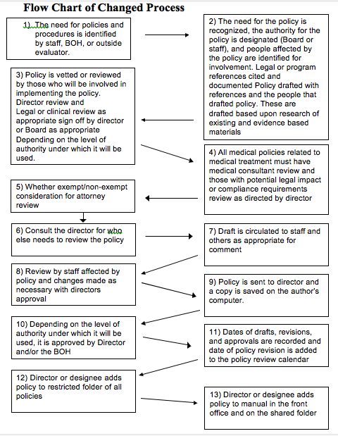
Solutions
1) Policies are added or changed to the current format seen below
POLICY TITLE:
POLICY LOCATION:
EFFECTIVE DATE:
DATE REVIEWED/REVISED:
AUTHORIZED BY: Jane Ford-Witthoff, Director
DOCUMENT LINK:
PURPOSE STATEMENT:
POLICY:
PROCEDURE:
REFERENCES/LEGAL AUTHORITY:
2)Policy is reviewed by staff & director
- Policy is added to the shared folder “Current Policies”
- Person who added the policy to shared folder adds their name to the Sign-in Sheet

