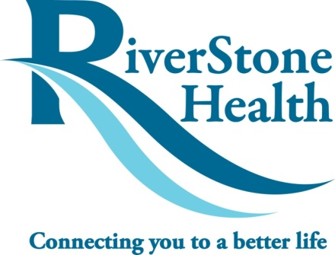
Engagement of Customers, Stakeholders, and Team Members in QI Projects: Effective Tools for Gaining Support of Those Who Matter

Presenters: Hillary Hanson & Hannah (Miller) Silveus, Yellowstone City-County Health Department dba RiverStone Health (Billings, MT)

QI tools and strategies to assist with engagement:

Recognize all stakeholders: Who is currently involved in the process? Who is contributing time and resources? Who will be impacted by the project?

Data collection: What do you want answers to? Who has these answers? Who is going to evaluate and process the results of the data collection?

Meeting evaluations: Assess and address the morale of the QI team—a safe way to raise concerns and give out kudos.

Flowcharts: Involve team members and “front-line” individuals in building or re-defining the process to identify gaps and opportunities for improvement.

Brainstorming: Group brainstorming builds trust, promotes participation of all team members, and is time-efficient.

Group decision making: Use a form of weighted multi-voting to allow for each team member to be part of the decision making.

Resources and References

Presenter Information:
- Hillary Hanson, Director of Population Health Services: hillary.han@riverstonehealth.org
- Hannah (Miller) Silveus, Prevention Health Specialist: hannah.sil@riverstonehealth.org

General Resources:
- “Embracing Quality In Public Health: A Practitioner’s Quality Improvement Guidebook” is a downloadable document that contains great information about identifying customers, clients and stakeholders, drafting valid surveys and interview questions, and developing flowcharts. It can be accessed by following this link: http://mphiaccredandqi.org/Guidebook.aspx.

- “The Public Health Memory Jogger II” provides detailed information on how to use Nominal Group Technique (NGT) or multivoting.

- For any documents used during RiverStone’s WIC QI project, contact Hannah at the email above or by phone at (406) 651-6537.

Notes:

