Project Team: DeKalb County Death Filings
Timeline: Begin 3/17/2014; end 3/21/2014; performance outcome assessment: 4 weeks

SOLVE
What is the Approach?
9. Team Members & Roles
10. Project Schedule
11a. Data and Information Collection
What are your Conclusions?
13. Improvement Hypotheses & Problem Solving Summary
What is the Gap?
1. Starting Point
2. Vision
3. Current State
What is the Goal for Improvement?
4. Goal or Target Condition
5. Customers & Beneficiaries
6. Benefit
7. Measures & Targets
8. Conditions

SOLVE
TRY, LEARN, INSTALL
Try Solutions; what did you learn?
14. Construct & Execute tests
15. Document Results
16. Analyze Results & Extract Learning
How will you make the new way happen?
- Plan Rollout & Execute
- Measures of Success
Understanding the Problems:
11b. Current and Future State Process Maps
12. Cause and Effect Diagram

_ SOLVE _
1. Starting Point
- What is the need (e.g. outcome) or gap that caused this project to be considered in the first place?
The current process to gather data, validate and input death certificates in the Office of Vital Records (Office) requires significant human resources. These staff are being drawn from other duties, which affects resource leveling within the Office and negatively impacts the Office’s overall performance. The inability to file registrations in a timely manner results in delay of time-to-certificate for the public, and data to support public health surveillance activities. This also negatively impacts the revenue flow and increases expenses for personnel services due to the provision of additional staff resources.

b. Who is establishing the need?
The DeKalb County Board of Health has recognized that this is a business need, with the Office of Vital Records as an integral contributor to the overall process.

c. How is the need being measured and is it possible for this project to make an impact on that measure?
Number of FTEs required to process death certificates

d. What data or analysis was used to establish that this project will make a key impact?
The current amount of time to produce accurate filings, the number of filings each week, the one staff resource, and the number of weekly man-hours required to achieve the accurate weekly filings, which is currently 30% greater than 40 man-hours.

e. What scope (e.g. geographic, organization, customer) are you expected to impact?
Walk-in, long form certificates

f. What conditions are being placed on this project?
- One FTE max to be used for process
- State law compliance
- Targets are achieved within four work weeks of kaizen event completion

2. Vision (What do you want to achieve in the long range and without any restrictions? Generate a picture or description of your ideal condition. How will it look for the customers, our team, and for the taxpayers/funding sources?)
- Staff time is more efficiently utilized to achieve desired results
- Certified death records are accurate and available on a timely basis
- More time can be spent in education and training on the benefits of the state electronic system

3. Current State (Description of how the process and organization is operating now; Quantitative if possible, always factual and based on observation)
Stakeholder | Description | How do you know?  (Data if available)
Customers | - 25 county funeral homes  - Average 107 death filings in one work week | Manually maintained, which showed an inconsistency in filing regularity by the funeral homes. This resulted in downtime for staff and then accelerated effort by death clerk to meet customer service expectations for filing expectations.
Financial | - Revenue is delayed when filings are unavailable  - Expenses are increased through personnel costs and mailing costs when certificates must be mailed via USPS, FedX or UPS, instead of delivering onsite | Number of incomplete certificates at time of delivery from customer. Increased incoming errors require additional resources to validate data; requests for mailing of certificates/increased postage costs for those funeral homes not wanting to wait; and, observation of inadequate tracking and filing of certificates in process.
Your Team | - One (1) dedicated FTE  - Three (3) FTE | HR records. Current VR management frequently requested additional HR resources, such as an additional FTE, to offset the time required to process filings.

4. Goal or Target Condition (What is the objective? Which piece of the gap are you addressing?)
TO: Reduce time to file death certificate registrations. The cycle time for registration filing begins with the hand-delivery of certificate(s) by the funeral homes to the Vital Records Office. The process concludes upon creating an error-free custodial copy of the filing for eventual mailing to the State Office, as well as in-house printing of the requested certified copies.

5. Customers and Beneficiaries (Who benefits from achieving the goal? What populations are targeted?)
- Twenty-five (25) funeral homes
- Citizens
- Board of Health
- Public Health surveillance officials

6. Benefit (What are the benefits from achieving the goal?)
SO THAT:
- Funeral homes received state-certified documents more quickly
- Our resource requirements are reduced and can be applied to other value-added activities
- Data to support surveillance activities is submitted to State Registrar more timely

7. Measures and Targets (What quantitatively will be achieved?)
Beneficiaries | What Measured | How Measured | Target
 |  |  | How Much | By When | Actual
Funeral Homes, DeKalb Team | Current cycle time | Document time cycle from receipt of death data to certification processed (in “red folder” | Reduce cycle time by 30% (for same number of copies required) from current performance (15-20 min). | 4 weeks after event | Cycle time reduced by 56%, going from an average of 22 minutes per certificate filing pre-Kaizen to the current and continuously reduced average of less than 9 minutes per certificate filing.
Funeral Homes, Dekalb Team | Incoming defect rate | Defective certificate requests received from Funeral Directors (1st pass, as submitted the first time) | Reduce by 50% from current perceived rate of 90% defective (missing or incorrect information) per each certificate. | 4 weeks after event | Error rate reduced by 38% in two weeks following Kaizen event, based on pre-Kaizen error rate (9 of 10 received certificates contained errors. Now, 5.5 of 10 received certificates contain errors). This number continues to trend downward as funeral directors are educated in errors made, as well as their self-correction.
 | Electronic filings | Trend number of weekly filings | No desired trend; for tracking and comparison ratios only | Go live

8. Conditions (What do you need to be successful?)
- Use Board of Health POS system
- Track county-certified copies of death certificates
- Required level of customer service is delivered
- Birth and death customers receive same priority levels
- Live (present customer) receives priority over calls

9. Team Members and Roles (Who is directly involved and How?; Training Needs?)
Name | Role | Work process related interests / concerns | Project Expectations | Project, QI skills
Wanda Cason | Process Owner | County Registrar | Participant | SME
Dianne McWethy | QI Leader | BOH | Leader | Kaizen
Susan Floyd | Co-Leader | BOH | Co-Leader | Kaizen
Trishuna Brown | Processor | BOH | Participant | SME
Debbie Johnson | Processor | BOH | Participant | SME
Hannah Gary | Process Co-Owner | BOH | Participant | SME
Jacqueline Hill | Wild Card | BOH | Participant | SME

10. Project Schedule (Activities to go about solving the problem)

- Day 1: Get focused; checking our goal; looking for the value and wastes
- Day 2: Analyze the wastes and identify solutions
- Priority issues: Incoming defects from customers; inconsistent evaluation of required data; redundant, inconsistent processes; excessive motion to accomplish tasks; phone calls routed to incorrect locations.
- Day 3: Start creating the future state
Root Cause Areas: Phone tree and routing functionality; requirements for acceptance and verification of data; work process and standardization; and, key service and policy gaps.
Building the Future State: Less defects, motion, interruptions, duplication and, less labor, process steps, better quality and less frustration
- Day 4: Developing Solutions and Job Aids to Enable the New Process
- Day 5: Testing and Learning
- Beyond Day 5:Continuing to develop solutions and the future state
- Standardized work and clear roles established; operating policies revised
- New intake materials to reduce defects
- Scanning system and log
- Verification checklist
- Revised phone system
- Revised office area layout
- Our Rollout: Operational measures completed; office scanning set up; training materials completed; phone system operational; continual improvement system set up; GO LIVE March 31

11a. Data and Information Collection (What will you collect? Who? When?)
WHAT | WHO | WHEN
Observe current state of “long form” death certificate process; collect process step and overall times, waste observations, “spaghetti chart” of motion patterns required for process, and documents produced. | J. McKeever: motion; waste observation: all; Team, Susan and Dianne: job aides; Team: process steps | During Kaizen and ongoing as part of Continual Improvement System
Overall data for certificates: # processed by day/week, type. | Death Clerk, Supervisor | During Kaizen and ongoing as part of CIS
Incoming defect rate (how frequently the incoming information is incomplete or incorrect) | 9 of 10 | During Kaizen

11b. Observe and Document Current Process (Generate a Process Map)

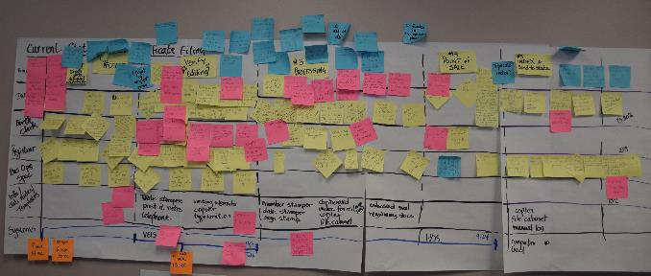

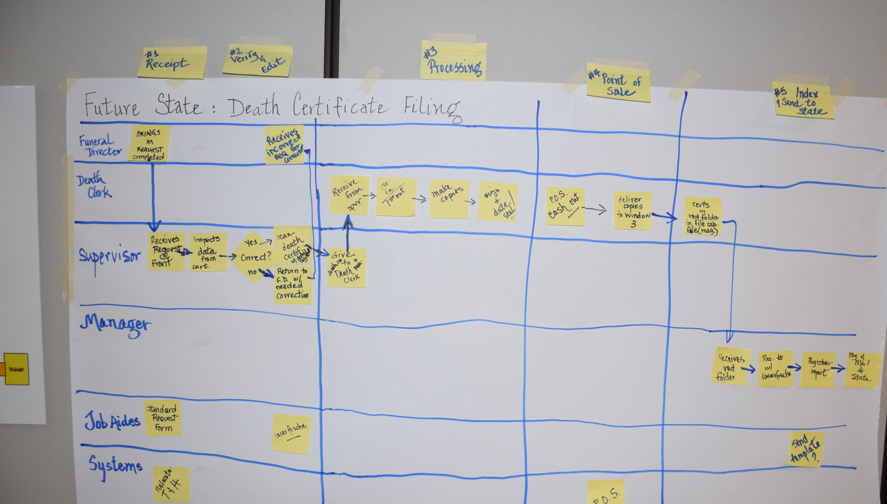

12. Conduct Cause and Effect Analysis (Priority issues and solutions from Cause and Effect Analysis)
Category | Issues/Wastes | Root Causes | Solutions or Additional CI Methods to use | Speed and Cost to Implement
Process step: Certificate processing | Waste: Stopping (interruptions due to phone calls to death clerk) | Incoming Phone tree and website not effective in providing information to customers due to length, accuracy and clarity of key information.  Routing of calls not consistent with organization policy, not designed to reduce interruptions to death clerk.  Organization policies do not exist to establish service level agreement, priority setting, and process coverage. | Policy statements | Within kaizen event
Process step: verify/edit | Waste(s): Not needed.  Birth data verification,  Waste: Things Gone Wrong, Movement.  Verification of individual data fields | State standard not clear as to requirement for verification and leads to inconsistency and confusion in application  No inspection standards for content of individual data fields exist; organization policy for whether DeKalb or Funeral director is responsible does not exist | Review state policy; Standardized work  Standardized work; visual job aids for Dekalb and Funeral Directors; redesign process to require correct and complete data as part of receipt | Within kaizen event  Within kaizen event
Process step: certificate processing | Waste: Not needed  Redundant tracking logs  DeKalb process steps: Verification and inspection (final manager inspection) | Multiple logs believed required to ensure traceability; work process not standardized nor examined for how reliable traceability is achieved  Team member roles and responsibilities not clear/established as to who does what, the individual’s accountability for self-inspection; work process not evaluated for how defects can be eliminated without inspection | Stop manual log; Process redesign, standardized work and use of document scanning system to electronically track  Process redesign, standardized work; visual job aids | Within kaizen event

Process step: certificate processing | Waste: Stopping (interruptions; team members at death clerks desk) | Lack of role clarity, no process for identifying overloads(help) and addressing | Process redesign so death clerk initiates request for help; standardized work; visual job aids | Within kaizen event
Process step: certificate processing | Waste: Stopping (interruptions) and Movement (office organization) | Death clerk physical location promotes interruptions by funeral directors | Redesign process to have supervisor provide intake part of process; move death clerk to location away from receiving window | Within kaizen event

13. Improvement Hypothesis (Summary of potential means to achieve goal)
Issue | Improvement | Expected Results
Incoming defects | IF…we redesign the request form, provide clarity and feedback to the Funeral directors as to frequently missed or corrected items AND we standardize our acceptance criteria for review of data… | THEN…incoming defect rates will drop and interruptions to the death clerk and will be reduced.
Consistency of process | IF… we redesign our process to utilize the supervisor for intake, standardize and clarify roles and responsibilities and have the death clerk only receive “help” when it is requested… | THEN…labor required to process will be reduced and the consistency of the process output will be improved
Travel motion | IF… we move offices and equipment to match the work process... | THEN…travel for performing process steps, interruptions from other team members and labor required will be reduced
Redundant operations | IF…we introduce scanning hardware, software and a process for its use during initial receipt of documents… | THEN…redundant logs and processes can be eliminated and labor reduced without sacrificing traceability
Getting customers correctly routed for answers | IF…we redesign the phone messaging prompts and redesign the routing/rollover system so that it is shorter, clearer to customers and provides needed information… | THEN…customers will get their information faster with less transfers and there will be less interruptions to non-involved team members

_ TRY _
14. Test Hypotheses (How will you test the potential solutions?)
- Update the project schedule For trial and learning)
Tests | How | When | Who | Successful if…
Future state work process run though | Take sample request form and data and run through new process by role and using job aids | March 28 | Susan and Team | Process successfully achieves final deliverable; no more than 3 required changes identified
Phone tree (message) | Have 3 customers (birth and death) listen to new messaging, and attempt to access needed information | March 28 | B. James, H. Gary | All customers respond favorably on 5 point scale that improvement over prior messaging made.
Routing (functionality) | Call in from external source and observe sequence and timing | March 31 | All | Sequence and rollovers correct by process role
New Request form template (with visual guidelines) for Funeral director | Try new form with 3 Funeral directors; observe % of defective data received and reported ease of use | March 27 | Susan | Defective requests reduced by 50% from assumed 90% level.  All Funeral directors report requirements clear.
Data request inspection checksheet for Dekalb team | Give 3 members a common death certificate request and use the checksheet to establish what is acceptable/not acceptable | March 28 | Wanda | 90% of all fields are judged similarly by all 3 members
Scanning process and hardware | Install and run 5 records through | March 28 | IT with Hannah | Hardware/software combination successfully scans, records and increments the record number window 3 station

15. Results: attach graph/table of actual trial performance

Step | Action | Result
Request funeral director to review the revised request form | Two funeral home representatives reviewed the form and offered suggestions | Suggestions were incorporated into final form
Inspect death filing | Using the inspection guidelines, three staff were asked to review a death filing | The guideline was followed, with all errors noted in the filing, marked and returned to the filer (this was a mock exercise)
Dedicate one intake window for funeral filings only | Using a stanchion and window markings, direct all funeral staff to the #3 window | Funeral staff go directly to this window; there is no comingling of public consumers with death filings
Phone tree modified to provide more adequate information, in Spanish and English. Direct dial numbers modified for death clerk to redirect caller to birth clerk or leave a voice mail, if clerk cannot answer telephone call. | Call in to main number and follow prompts. Call in to individual direct dial numbers and follow prompts. | Switchboard continued to direct incoming calls to death clerk. This has been changed. All staff are able to access any voice mail left from main number. Significant reduction in interruption for death clerk by telephone calls: she has been asked to focus on her filings. All staff are in the same pick-up group and are able to answer a ringing phone, if available.
Death clerk is the only processor for all death filings | After supervisor inspection of death filings, only corrected versions are received from funeral homes. These are received by the death clerk only. | The process is a cleaner more efficient manner in which to perform death filings. We will continue to monitor this process and implement other CIS actions, as necessary.

_ LEARN _
16. Learning (For the trials, what worked and did not, why and what are you doing as a result? Is the result repeatable?)
Reasons | Learning: Why? | Direction: Actions to be taken
Inspection guide sheet was created for reviewing incoming death files | Provides a uniform checklist for inspecting files. Allows staff to note errors for funeral directors to correct. | Continue to enforce the process for funeral directors to make their own changes. Educate funeral homes on process for review.
Created a protocol for all Vital Records staff | Documented the responsibilities and accountabilities for each staff person. Other non-death staff will not implicate themselves into the death filing process unless requested by death clerk. | Continue to adhere to protocols by all staff
Created job aides:  Funeral home filing request  Instructions for funeral homes for death filing input  Instructions for funeral homes for preview of documents via fax or email | Segregating the forms from the consumer-driven requests for death or birth certificates allowed for expansion of instructions, as well as documented internal processes | Continue to use dedicated request form. Widespread distribution of forms, with instructional packages to all incoming funeral homes.
Reorganization of work area:  Dedicated intake window  Dedicated copier for death filings  Relocation of death clerk work area | Supports the protocol by keeping all staff within their lane. The death clerk now has a streamlined work area which supports more efficiency, reduce the wastes of motion, specifically. | Continue to support the death clerk and the death clerk process.
Assignment of supervisor as inspector of incoming filings | Reduce the amount of processing time in a uniform manner | Cross-train all staff in inspection process.
Implementation of scanning software for death filings | Replaced three manual processes/logs for recording the receipt and maintenance of custodial copies. | Continue scanning of all incoming filings; scan historic documents not present in state system.
Funeral director training on state GAVERS system | Will continue reducing the time of processing if funeral homes adapt to use of the electronic system and rely less on the manual forms | May 14 class set up for training with the maximum of 12 funeral home participants attending. There is currently a waiting list, so training on a quarterly basis will continue
Telephone messaging: general phone installed and messaging changed | The continuous telephone interruptions initiated a review of the current state. Messages were re-recorded, directing incoming to death/birth/funeral home selections, along with main menu selections for location/cost and other options. The main switchboard was also requested to direct calls to the auto-attendant. | Incoming calls are logged into subject categories. Staff will continue to log all calls. Once available, the call accounting system will be used for reporting of incoming/outgoing calls.
Continual Improvement System | Since the go-live date, the staff have identified and implemented solutions in other areas to reduce waste. | The staff will continue to identify issues and opportunities, using the fishbone diagram installed in their office (CIS).

_ INSTALL _ 17. Installation Plan (Steps to operationalize the new process and make it stick. Attach new process map below.)
- Operationalize measures 25 MAR
- Office scanning setup 25 MAR
- Finish Training materials 25 Mar
- Set up Continual Improvement System (CIS) 27 Mar
- Conduct training and observations 27-28 Mar
- Phone system operational 28 Mar
- GO LIVE! (31 MAR)
- 1st CIS “Standup” Team review 4 APR

Vital Records Continuous Quality Improvement Actions
Implemented changes since Kaizen go-live date
Issue: Death Clerk was experiencing continuous interruptions from other staff, including use of the dedicated work area for other staff needs.
Root Cause:
Death Clerk’s work area was in close proximity to other work areas, filing cabinets and intake area for other requests.
Implemented Solution:
- Physical layout of the office
  - Copier in the back room removed
  - Cabinet in the back room removed
  - Death Clerk work area relocated to back of office area away from other work processes

Issue: Redundant manual tracking methods employed to maintain location of filings
Root Cause:
Staff were not trained or did not use available scanning software, with unique tracking and query capability
Implemented Solution:
- Installed laserfische software to enable scanning of all incoming death documents.
- Custodial certificates are maintained and can be retrieved from the electronic filing system
- Scanning was set up to scan in regulation 8 ½ x11 sized paper
  - Eliminated the need for legal-size security paper through the certificate scanning process, thus saving a significant amount of money as well as time

Issue: Custodial certificates were hand-signed and embossed at the time of filing, including up to 10-15 copies at one time
Root Cause:
- Staff did not have personalized signature stamps, which are allowable
- Staff had not test embossing of security paper prior to printing in bulk
Implemented Solution:
- Emboss and sign birth and death paper at the start of each day before business begins

Issue: Incoming errors from funeral homes were at unacceptable rate of 90% per filing, with the staff making all corrections
Root Cause:
Staff were making the corrections and not educating the funeral homes as to their responsibility related to corrected filings
Implemented Solution:
- Dedicate one staff to inspect all incoming filings, using new job aid (inspection form)
- Note all errors on filing and return to funeral home representative
- All funeral homes make their own corrections
- Vital Records staff do not take receipt of filings until all corrections are made
- Revised directions to complete filings, as well as new request form, were given to each funeral home
- Funeral homes were informed that all corrections would be made by them, not Vital Records
- Training on State electronic GAVERS system to be offered to assist funeral directors in inputting all information into the system, eliminating the need for Vital Records manual inspection

In-Process Changes
Issue: Funeral directors do not use electronic GAVERS system
Root Cause:
Vital Records staff made all changes/corrections to paper filings
Implemented Solution:
- Vital Records, in conjunction with State, has offered two (2) inhouse trainings on GAVERS system. Both trainings have been at capacity.

Issue: Staff not adequately trained in using Microsoft or Laserfische software
Root Cause:
Staff did not have adequate backup to attend training sessions
Implemented Solution:
- Two staff from outside Vital Records have been trained, allowing staff to attend training classes.

Issue: Majority of phone inquiries are related to location and cost
Root Cause:
Information is not readily available without making a phone call to staff
Implemented Solution:
- Re-recorded telephone messaging with correct location and cost information.

Future State Changes
Issue: Vital Records information, including purchase information, is not readily available on website
Root Cause:
Website does not list address or payment information; cannot submit or order online
Implemented Solution:
- Publication of dedicated email address, with encouraged use by funeral directors.
- New, user-friendly website
- Online ordering through our county office

18. Measure Success attach graph/table of installed performance

The average number of errors per filing was 9, for 2013. This led us to create an internal job aide, detailed instructions and revised request form for the funeral homes and a dedicated staff inspecting each file. This has resulted in a drop in the error rate to just over 5.5 in 14 work days, or 38% reduction. Our goal is to reduce errors by 50% within a one-month time frame. As the submitters are learning of their most common errors and the ease to correct, the error rate is expected to continue to drop.

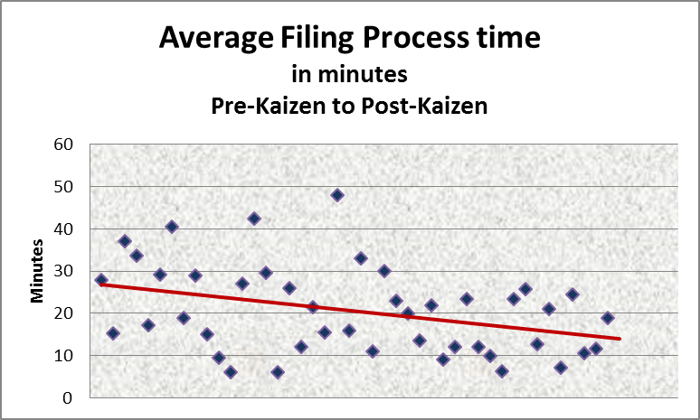
Pre-Kaizen
Post-Kaizen

Averaging over 20 minutes per filing process, changes in the inspection of incoming certificates, reliance on the funeral home representative(s) to make changes, reduced motion by rearranging work areas, minimizing interruptions by repositioning death filing area and revamping telephone messaging has resulting in a reduction of filing process time by over 50%.

A sampling of incoming telephone calls from the public indicated that the vast majority of inquiries dealt with the Office's hours, location and cost.20% of these calls were for the death clerk but sent to the birth clerk and were subsequently forwarded to the correct staff. This led us to assess the current available public information; revamp the website; create and distribute informational documentation to the health centers, security guard desks, pediatricians, schools and hospitals. Other efforts included recording a new message for our telephone auto-attendant conveying the office hours, location and cost. Direct dial numbers also gave these options, as well as an option to leave a message for the death clerk or file clerk.

