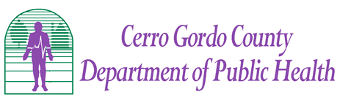

Our Mission: The Cerro Gordo County Department of Public Health works to optimize the health of all people in Cerro Gordo County.

**Increasing Pneumococcal Vaccination Rates for seniors in Cerro Gordo County**

July 1, 2015 – January 31, 2016

**Background**

The Pneumococcal polysaccharide (PPSV23) vaccination coverage rate for those aged 65 years and older in Cerro Gordo County in 2014 was 53%, well below the Healthy People 2020 goal of 90%. In October 2014, the Advisory Committee of Immunization Practices (ACIP) began recommending the Pneumococcal conjugate (PCV13) vaccination, in addition to the PPSV23, as a routine vaccination to all adults 65 years and older. The Pneumococcal conjugate (PCV13) vaccination coverage rate for those aged 65 years and older in Cerro Gordo County in 2014 was 4%. This project was chosen to help achieve the goal of reducing hospitalizations and death rates associated with pneumococcal pneumonia as well as attain an overall healthier population in Cerro Gordo County.

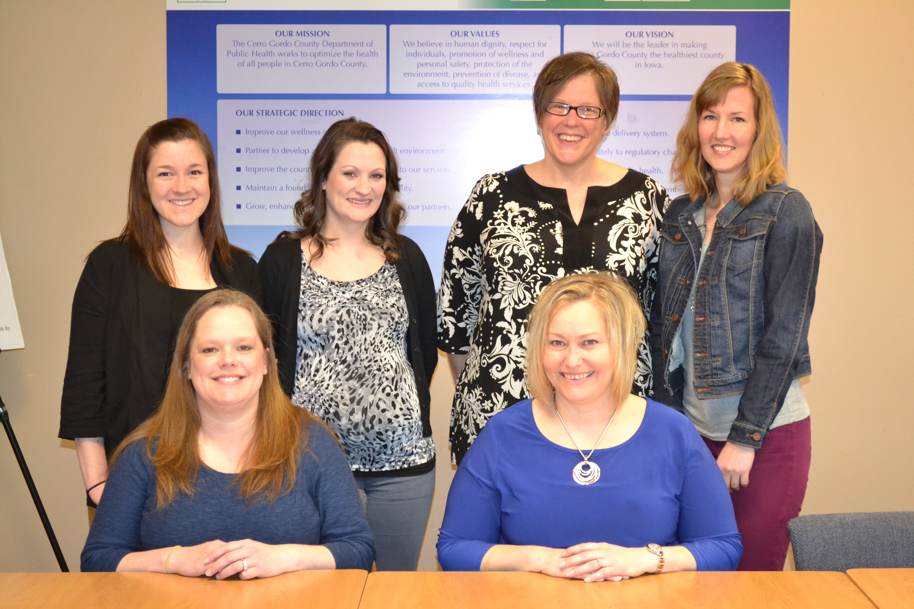

**Assemble the Team**

Team Leader: Bethany Bjorklund, Immunization Nurse

Scribe: Jodi Willemsen, AIDEP Service Section Manager

Team Member: Jennifer Stiles, Infection Control Nurse

Team Member: Sandy Pals, =AIDEP Administrative Aide

Team Member: Kara Ruge, Public Information Officer (PIO)

QI Coordinator/Facilitator: Kara Vogelson, Organizational Development and Research Manager

**PLAN**

**Problem Statement:** The pneumococcal vaccination rate for those aged 65 and older is low.

**Aim Statement: Increase the pneumococcal vaccination rate by 5% for Cerro Gordo County residents aged 65 and older by 1/31/2016.**

**Current Approach**

* Lack of reliable county wide data for target population in Iowa’s Immunization Registry Information System (IRIS). Only pharmacists are required by law to enter pneumococcal vaccinations administered.
* The Cerro Gordo County Department of Public Health’s (CGCDPH) immunization program has a strong focus on childhood & adolescent immunizations.
* No standardized procedures for the immunization clinic or at outreach influenza clinics to routinely check immunization records and have the ability to offer both pneumococcal vaccines at outreach influenza clinics.
* Missed opportunities due to the lack of knowledge about the new PCV13 recommendations for patients, providers, pharmacies and other health care personnel within the health department.

**QI Tools Used**

* **Cause & Effect Fishbone Diagram (see below)** was created to help our team identify, explore, and graphically display, in increasing detail, all of the possible causes related to our low pneumococcal vaccination rates. This process allowed our team to focus on the content of the problem, not the history of the problem.



* **Force & Effect Analysis (see below)** was completed as a team to identify the forces and factors in place that support or work against the solution as to why our county pneumococcal vaccination rates were low so that the positives can be reinforced and/or the negatives eliminated or reduced. This process helped our team select targets for change.

|  |  |  |
| --- | --- | --- |
| **Force & Effect Diagram**  Key: S= Strong M= Medium W= Weak | | |
|
|  | (s) lack of data in IRIS for target population (pharmacies, physician office, nursing homes, hospital, clinics don’t participate in IRIS) | **Increase 5% by January 31, 2016** |
|  | (m) people doctor out-of-area |
| (s) target population receptive to vaccination | (m) building access/visibility |
| (s) physicians encourage vaccination | (m) finding data/medical records (data exchange) |
| (s) funding sources (Medicare, PAP) | (s) focus on children/adolescents |
| (m) baby boomers aging to target population | (m) patient refusal |
| (w) database available to document (IRIS) | (m) ability of patient to leave home |
| (m) national promotion/media for vaccine (PCV-13) | (s) limited funding for advertising & staff time |
| (s) vaccine availability | (m) negative media/perceived risk |
| (s) convenience | (m) some physician offices won't give vaccines (patient must access elsewhere) |
| |  | | --- | | **positives** | | |  | | --- | | **negatives** | |
| **PPSV23 = 50% PCV13 = 4%** | |

**Identify Potential Solutions**

* Develop a standardized procedure to screen all adults 65 years and older for other immunizations recommended during their visit to the immunization clinic.
* Improve accessibility to Iowa Immunization Registry at outreach clinics and offer both pneumococcal vaccinations at influenza outreach clinics.
* Educate all clinic staff on ACIP Pneumococcal vaccination dosing recommendations and Medicare reimbursement guidelines.

**QI Tools Used**

* **Solution & Effect Diagram (see below)**



* **Nominal Group Technique** allowed our team to quickly come to a consensus on the relative importance of increasing our pneumococcal vaccination rates by completing individual importance rankings into a team’s final priorities. This technique allowed our team to build an immediate commitment to the choices through equal participation in the process.
* **Impact Difficulty Matrix** was created as a team to identify and analyze all potential solutions to improve our pneumococcal vaccination rates. Our team focused on choosing solutions what were categorized as low difficulty/high impact instead of focusing on high difficulty/low impact solutions.

**DO**

**QI Tool Used**

* **GANNT Chart** was a tool that used horizontal bars to show which tasks can be done simultaneously over the life of the project by which team member(s).

**Solutions chosen:**

* Promote that pneumococcal and flu vaccine are both available at outreach flu clinics.
* Direct provider education to adults aged 65 years and older.
* Develop new methods for vaccine dissemination at outreach clinics.
* Educate vaccine providers (pharmacies, nursing homes, assisted living sites and medical providers) regarding ACIP recommendations and importance of both pneumococcal vaccines.
* Create a procedure for outreach flu clinics to include both pneumococcal vaccinations.
* Work with area medical providers to increase vaccination rates in Cerro Gordo County.

**The team implemented a number of interventions during the course of the project with specific deadlines for each task:**

* Worked with PIO to include in media advertisements and flu promotions that pneumococcal vaccinations will be readily available for all clinics.
* Developed a post card reminder to hand to the patient that included all vaccines recommended with health department’s immunization clinic and contact information if a patient refused the pneumococcal vaccine at the time of receiving the flu vaccine. Post cards were also given to local physician offices to give to their patients if referring them to get the vaccine elsewhere.
* Educated all nursing staff and direct administrative staff at health department on ACIP pneumococcal recommendations
* Created a pneumococcal dosing cheat sheet to have available at immunization and outreach flu clinics for all staff.
* Encouraged all staff to provide a strong recommendation for patients to receive the pneumococcal vaccine at the same time as the flu vaccine.
* Educated patients and staff on the difference between the two pneumococcal vaccinations available and the importance of receiving the vaccination.
* Reviewed health department’s home care patient’s vaccination needs prior to nurses making home visits with flu vaccine.
* All AIDEP nurses will have access to Surfaces and Blue Tooth internet devices at outreach clinics to review all patients’ immunization records.
* Determine which agencies (pharmacies, nursing homes, assisted living sites, medical providers) routinely access and record vaccinations into IRIS.

**CHECK**

Once the team began the “Do” phase of QI, it was quickly determined the majority of adults 65 years and older needed the PCV13 instead of the PPSV23 vaccine.

**Outcome tracking from July 2015 - January 2016 by evaluating:**

**Pneumococcal Vaccine Total Monthly**

**Doses Administered Report by CGCDPH**

**432 total doses administered**

**July 2014 - January 2015: 52 total pneumococcal doses were administered by CGCDPH**

|  |  |  |
| --- | --- | --- |
|  | **2014\*** | **2015^** |
| **PPSV23** | **43** | **8** |
| **PCV13** | **9** | **424** |
| **Total Doses** | **52-** | **432+** |

**CGCDPH Pneumococcal Vaccination Revenue and Total Doses Administered**

|  |  |  |
| --- | --- | --- |
|  | **2014\*** | **2015^** |
| **PPSV23 revenue** | **$4,975.31** | **$897.36** |
| **PCV13 revenue** | **$1,567.78** | **$78,143.20** |
| **Total revenue** | **$6,543.09** | **$79,040.56** |

**Key:**

**\***July 1, 2014 - January 31, 2015

**^**July 1, 2015 - January 31, 2016

**+**Of the 432 total pneumococcal doses administered during the QI Project, 44% of adults aged 65 years and older served by CGCDPH received a pneumococcal vaccination.

**-**Of the 52 total pneumococcal doses administered the previous year by CGCDPH only 4% of adults aged 65 years and older received a pneumococcal vaccine.

**Cerro Gordo County Vaccine Coverage Rates**

Pneumococcal conjugate Vaccine (PCV13)

*Adults 65 years of age and older*

|  |  |  |  |
| --- | --- | --- | --- |
| **Date** | **Total County Residents with**  **1 dose PCV13** | **Total County Residents\*** | **Percentage Vaccinated** |
| **7-1-2014**  **through**  **1-31-2015** | **621** | **14,758** | **4%** |
| **7-1-2015**  **through**  **1-31-2016** | **2,328** | **14,758** | **12% increase!**  **16%** |

**PPSV23 vaccine county coverage remained the same:**

* Start: July 1, 2015 = 53%
* End: January 31, 2016 = 52%

**Top Successes:**

1. The QI Project created a new procedure to implement a best practice standard of routinely checking every patient’s immunization records prior to administering vaccinations whether at the immunization clinic or at influenza outreach clinics.
2. Staff capacity increased during the peak immunization clinic months of September-November by having an administrative aide and/or AIDEP Service Section manager available to screen immunization records of patients’ and notifying the administering nurse to educate and offer the vaccination to all eligible patients.
3. Strong pneumococcal vaccination recommendation by public health staff and local providers lead to more patients receiving the vaccine.
4. County immunization coverage rates for PCV13 increased 12% throughout the course of the QI Project.

**Top Barriers:**

1. Agencies in our state who serve a large population of adults 65 years of age and older do not use IRIS, resulting in inaccurate pneumococcal vaccination rates for Cerro Gordo County.
2. IRIS does not have the capability to provide a county wide benchmark report for PCV13 vaccine coverage rates in adults 65 years of age and older in its reports section of the website. The IRIS Help Desk was able to provide this statistic upon special request.

**ACT**

**Standardize the Improvement**

* Continue to review every patient’s immunization record at time of visit and offer all recommended vaccinations at the health department’s immunization clinic.
* Continue to review all adults 65 years of age and older immunization records at outreach flu clinics for 2016-2017 and provide both pneumococcal vaccinations to those who are in need of them.
* Continue to educate patients, health department staff and other vaccine providers on the importance of pneumococcal vaccinations for adults 65 years of age and older.

**Future Plans**

* Partner with local healthcare provider to mail letters to all healthcare partners in the state of Iowa to encourage routine use of IRIS for the documentation of all immunizations given at their clinic sites.
* Relay concerns of inaccurate immunization data for all adults in IRIS to the Iowa Department of Public Health’s Immunization Program Bureau Chief and Iowa Immunization Coalition.
* Continue to gather county pneumococcal vaccination rates on a semi-annual basis (July and January).
* Analyze semi-annual data to determine if theory continues to achieve the desired outcomes.

**Sources of Data**

* Iowa Immunization Registry Information System (IRIS)
  + County Wide Benchmark Reports
  + Doses Administered Reports
* Centers for Medicare & Medicaid Services
  + Pneumococcal vaccine reimbursement rates (2014, 2015 & 2016)