**Project Team:**  **Team T-Drive Alive!**  (April Harris, Georgia Heise, Kim Hudnall, Greg Ramey, Lindsey Tirey)

**Timeline:**  January – March 2014

**SOLVE**

**What is the Approach?**

9. Team Members & Roles

10. Project Schedule

11a. Data and Information Collection

**What are your Conclusions?**

13. Improvement Hypotheses & Problem Solving Summary

**What is the Gap?**

1. Starting Point

2. Vision

3. Current State

**What is the Goal for Improvement?**

4. Goal or Target Condition

5. Customers & Beneficiaries

6. Benefit

7. Measures & Targets

8. Conditions

**SOLVE**

**TRY, LEARN, INSTALL**

**Try Solutions; what did you learn?**

14. Construct & Execute tests

15. Document Results

16. Analyze Results & Extract Learning

**How will you make the new way happen?**

1. Plan Rollout & Execute
2. Measures of Success

**Understanding the Problems:**

11b. Current and Future State Process Maps

12. Cause and Effect Diagram

_ SOLVE _

1. Starting Point

1. **What is the need (e.g. outcome) or gap that caused this project to be considered in the first place?**

The “t-drive” is a shared internal network drive, intended to be the central repository of information for use by all employees of Three Rivers District. There are both open areas providing read/write access to all employees and areas with limited access to certain groups or individuals within Three Rivers. Currently the t-drive is primarily used by administrative and management staff, and utilization by front-line and middle-level staff is very limited. Three Rivers serves a four county district, with five worksites, so there is a great need for all employees to use a shared internal network drive to facilitate the storage and access of information.

1. **Who is establishing the need?**

As part of developing the strategic plan in 2009, a SWOT analysis conducted by management and supervisory staff identified “lack of staff computer competence” as a weakness. Anecdotal data from discussions with TRDHD's Management Team, Quality Improvement Team & our IT Manager, suggests and important next step would be to increase the effectiveness, efficiency & utilization of the t-drive. Our Strategic Plan also includes many goals, objectives & action steps associated with documentation maintenance and utilization of the t-drive. Additionally, staff report issues accessing the t-drive or finding documents on the t-drive.

**c. How is the need being measured and is it possible for this project to make an impact on that measure?**

No measures of t-drive utilization were in place prior to initiation of this project. As part of the preparation for this project and event, a staff survey was conducted to gauge current usage and associated issues.



**d. What data or analysis was used to establish that this project will make a key impact?**

Primary data used was the staff t-drive utilization survey. Analysis of this survey indicated 2 key areas for improvement – improve the ability to find documents on the t-drive, and close key knowledge gaps in how to effectively and efficiently use the t-drive.

**e. What scope (e.g. geographic, organization, customer) are you expected to impact?**

* Include all employees in all five worksites

**f. What conditions are being placed on this project?**

* Targets shall be achieved within one month of kaizen event completion.

2. Vision(What do you want to achieve in the long range and without any restrictions? *Generate a picture or description of your ideal condition.* How will it look for the customers, our team, and for the taxpayers/funding sources?)

All TRDHD staff understand what the t-drive is to be used for and how to use it, and can consistently and efficiently find, store, and maintain documentation on the drive.

3. Current State (Description of how the process and organization is operating now; Quantitative if possible, always factual and based on observation)

|  |  |  |
| --- | --- | --- |
| Stakeholder | Description | How do you know?  (Data if available) |
| Customers  (EMPLOYEES) | * Managers and Administrative staff appear to be the most proficient in accessing the t-drive, as well as uploading documents to the t-drive when appropriate. * Some staff may not access the t-drive at all, and some may access the t-drive with difficulty finding a file. * The current state of the t-drive is in disarray - there are over twenty-five primary folders, with a range of 5-125 housed in secondary folders. * The Public folder is the most utilized, and houses over thirty secondary folders and approximately one hundred documents that do not belong to a specific folder. The employee must have the background knowledge about what primary and secondary folder the desired document was located, and select the appropriate folders to access the document. * Staff lacks awareness of what documentation is stored on the t-drive & where it is specifically located. * The current process cycle time has a range of great variability. For example, if each employee was given the task of locating and accessing the Emergency Contact List (located on the t-drive, in the Public primary folder, within the Disaster Response secondary folder), the cycle time would range from approximately thirty seconds to several staff who would not be able to complete the task. | * Strategic Plan SWOT Analysis * Anecdotal comments * Pre-Event Survey |
| Financial | * There is no charge for using the t-drive. * Significant labor cost due by time spent searching for documentation maintained on the t-drive. | * IT Staff * Anecdotal comments * Pre-Event Survey |
| Your Team | See Customers/Employees |  |

4. Goal or Target Condition(What is the objective? Which piece of the gap are you addressing?)

To increase staff utilization of the t-drive in their work, consistent with the intent of the t-drive.

5. Customers and Beneficiaries (Who benefits from achieving the goal? What populations are targeted?)

* All Current Employees
* Future Employees
* Vendors/Customers affected by documentation stored on t-drive.

6. Benefit(What are the benefits from achieving the goal?)

So that all TRDHD Employees can consistently and effectively use the t-drive in their work, feel knowledgeable about navigating and utilizing the t-drive for documentation storage, and report that the t-drive is effectively and efficiently promoting public health administrative functions.

7. Measures and Targets (What quantitatively will be achieved?)

|  |  |  |  |  |  |
| --- | --- | --- | --- | --- | --- |
| Beneficiaries | What Measured | How Measured | Target | | |
| How Much | By When | Actual |
| Staff | Utilization of t-drive | Staff Survey - % responding “Yes, Always” to knowing how to access T-drive | 50% increase from baseline | 3/14/14 | 35% increase  5/13/14 |
| Staff | Utilization of t-drive | Staff Survey - % responding they use T-drive at least once per week | 50% increase from baseline | 3/14/14 | 8% increase  5/13/14 |
| Staff | Ability to Find a File | Staff Survey - % responding they can always find what they are looking for | 50% increase from baseline | 3/14/14 | 240% increase  5/13/14 |
| Staff | Time to Locate a File | Direct observation and timing | Less than 30 seconds | 3/14/14 | 5.7 seconds  2/13/14 |
| Staff | Accuracy of locating a file | Direct observation - % occurrence of finding correct file on first attempt | Greater than 75% | 3/14/14 | 100%  2/13/14 |

8. Conditions(What do you need to be successful?)

* Targets shall be achieved within one month of kaizen event completion.
* Scope: Event will focus on the entire t-drive.

9. Team Members and Roles (Who is directly involved and How?; Training Needs?)

|  |  |  |  |  |
| --- | --- | --- | --- | --- |
| Name | Role | Work process related interests / concerns | Project Expectations | Project, QI skills |
| April Harris | QI Leader | QI | Develop as Kaizen leader. | Facilitator for QI projects. |
| Georgia Heise | Director | Performance Management | Expand QI activity. | Facilitator for QI projects. |
| Kim Hudnall | Clinic Support | Clerical Processes | More effective t-drive. | Minimal QI activity |
| Greg Ramey | IT (Process Owner) | Technical | Purposeful project. | Moderate QI activity |
| Lindsey Tirey | Admin | Administrative | Expand QI activity. | No prior QI activity |

*Training Needs:* None

10. Project Schedule (Activities to go about solving the problem)

|  |  |
| --- | --- |
| WHAT | WHEN |
| Prep and gather data | Dec 2013 – Feb 9, 2014 |
| Conduct Kaizen Event | Week of Feb 10, 2014 |
| Update T-drive & supporting documentation | February 17-21, 2014 |
| Gather feedback and update site | February 24-28, 2014 |
| Training materials completed | March 7, 2014 |
| Training delivered | April 2, 2014 |
| Remove old T-drive structure | April 7, 2014 |

**11a.** **Data and Information Collection**(What will you collect? Who? When?)

|  |  |  |
| --- | --- | --- |
| **WHAT** | **WHO** | **WHEN** |
| Pre-Event Survey | April | 12/2013 |
| Process Observations | Kaizen team | Event Day 2 |
| Post-Event Survey | April | 5/2014 |
| Continual Improvement System | Kaizen Team | Monthly |

11b. Observe and Document Current Process (Generate a Process Map)



The current t-drive had 52 folders and 105 files that had not been placed into a folder. Most importantly, a defined purpose and process owner had not been assigned specific to the t-drive.

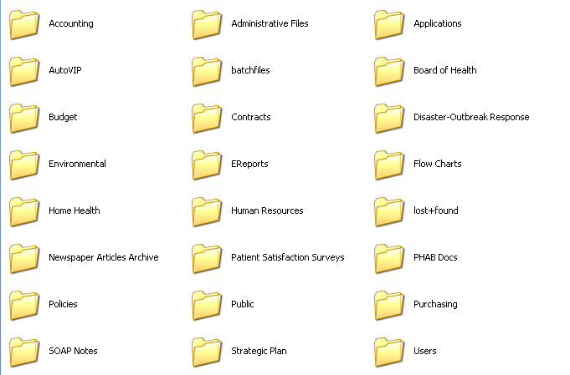

12. Conduct Cause and Effect Analysis(Priority issues and solutions from Cause and Effect Analysis)

|  |  |  |  |  |
| --- | --- | --- | --- | --- |
| **Category** | **Issues/Wastes** | **Root Causes** | **Solutions or Additional CI Methods to use** | **Speed and Cost to Implement** |
| Current organization of t-drive hinders workflow | * Lack of Organization of the T-Drive * Unable to locate correct folder for saving a file | * Structure organized by access * Structure not defined * T-drive evolved, not designed * No owner established for T-drive | * Eliminate Public folder * Create new simplified structure * Establish an owner for the T-drive | Priority 1 (high speed, low cost) |
| Current organization of t-drive hinders workflow | Lots of homeless files exist on T-drive | * Current structure does not provide an obvious location for everything * Random files on T-drive (e.g. hidden and temp files) * Files loaded which are intended to be temporary (e.g. sharing large files) | * Create new folder structure which provides a location for every file * Establish rule – no “homeless” files in root folders * Establish guideline which provides flexibility to create new subfolders as appropriate * Establish a procedure for maintaining new folder structure and no homeless files | Priority 1 (high speed, low cost) |
| Current organization of t-drive hinders workflow | Unintuitive File and Folder Names | * No naming guideline exists * Names aren’t descriptive, abbreviations and acronyms used * Structure was not developed before naming | * Establish a guideline for how to name files and folders * Develop new structure and make filenames consistent with structure * Establish standard set of subfolders in Department folders | Priority 1 (high speed, low cost) |
| Users Don't Know What is on T-Drive, Why to Use It, and How to Use It | * People don't know how they could benefit from using T-drive * People don't know what can/should be put on T-drive | * They were never told * No purpose defined for T-drive * No guidelines for how to use T-drive | * Conduct T-drive communication session at next all-staff meeting * Conduct training session on T-drive for all existing employees * Train on t-drive as part of new hire orientation * Develop a guideline for purpose of T-drive and what goes on there | Priority 1 (high speed, low cost) |

13. Improvement Hypothesis(Summary of potential means to achieve goal)

|  |  |  |
| --- | --- | --- |
| **Issue** | **Improvement** | **Expected Results** |
| Current organization of t-drive hinders workflow | If we establish a new, clean, standard folder structure for the T-drive with no “Public” folder | Then search time will decrease, frustration will decrease, and utilization will increase |
| If we define and communicate a guideline for the T-drive which clarifies the intent of the T-drive, ownership, how to use it, and how to maintain it | Then utilization of the T-drive will increase and backsliding to disorganization will be decreased |
| Users Don't Know What is on T-Drive, Why to Use It, and How to Use It | If we deliver training to all staff on how to use the T-drive (based on the established guideline) | Then users will be better prepared to use the T-drive and utilization will increase |

_ TRY _

14. Test Hypotheses(How will you test the potential solutions?)

* Update the project schedule (For trial and learning)

|  |  |  |  |  |  |
| --- | --- | --- | --- | --- | --- |
| **Tests** | **How** | **When** | **Who** | **Successful if…** | **Results** |
| Gather feedback on proposed T-drive structure | Present to stakeholders | During 2/12 meeting | Team | Positive feedback: Stakeholders agree new structure is acceptable and will be a significant improvement | Successful -- positive feedback received from stakeholders on proposed new structure |
| Gather feedback on proposed T-drive guideline | Email to stakeholders | 2/13 | Georgia | Positive feedback from stakeholders | Successful -- positive feedback received from stakeholders on proposed new guideline, including comments for improvement |
| Measure time and accuracy in finding a file | Observe and measure users (same as Day 1 observations) | 2/13 | Team | User can find file in 30 seconds or less | Successful -- users were able to find target files in 8 seconds or less (see Section15) |
| Gather feedback from users on new T-drive structure and guideline | Post feedback chart with post-its at each site; instruct users how to provide feedback; gather and review feedback weekly | 2/17 | Team | Users provide feedback to team using posted feedback charts | Unsuccessful -- Only one feedback post-it received |
| Communications feedback |  | On-going |  | Increased awareness, discussion, feedback |  |

15. Results: attach graph/table of actual trial performance

Results of user trials conducted during Kaizen Event:

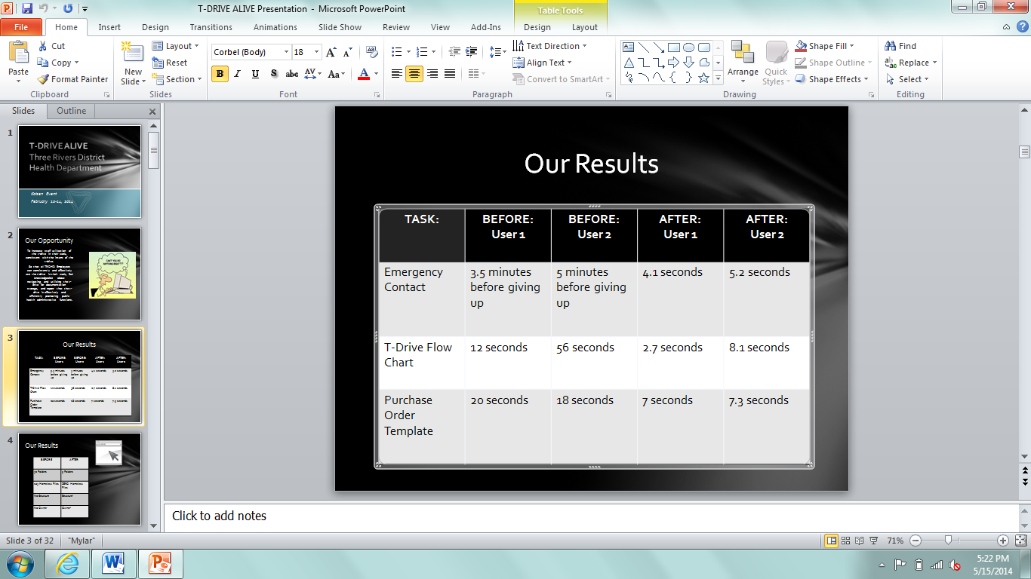

**_ LEARN _**

16. Learning (For the trials, what worked and did not, why and what are you doing as a result? Is the result repeatable?)

|  |  |  |  |
| --- | --- | --- | --- |
| **Reasons** | **Learning: Why?** | **Direction: Actions to be taken** | **Status** |
| Staff training | Staff rarely have time together as a department to receive IT training | Build in time with departmental staff meetings to follow-up with t-drive | Completed |
| Communication | More frequent communication about the project occurred: planning, implementation, and follow-up. | Continue to keep staff up-to-date through QI meetings | On-going & Completed |
| Logistics | Meeting rooms, IT needs, food, etc. were all planned ahead of time. | Consider arrangements in advance. | On-going |
| New structure of T-drive appears to have enabled users to find files on T-drive much more quickly and accurately. | Using intuitive naming for folders and decreased clutter (# folders, homeless files, etc) makes it easier to find files. Results suggest the root causes addressed for searching of files was successful. | Continue to periodically monitor adherence to new standards to ensure sustaining of new improved T-drive structure. | On-going |
| Post-survey on 5/13/14 indicates that utilization of T-drive has not increased as much as anticipated (e.g. 33% still indicate they never use the T-drive) | Selected causes for lack of utilization of T-drive may not have been correct, or solutions tried may not have been effective. | Gather more data on reasons for not utilizing T-drive and conduct another improvement cycle (root cause identified issues, try new solutions, measure results). | On-going |

**_ INSTALL _** 17. Installation Plan  (Steps to operationalize the new process and make it stick. Attach new process map below.)

The new structure of the t-drive will allow staff to access all agency documents more efficiently (see pictures of revised structure). Three folders are at the root of the t-drive: All One Team, Departmental, and Instructions for the T-drive. The All One Team folder mirrors the agency’s vision statement; it contains general documents housed in ten folders. The Departmental folders represent each department/group of staff in the agency. Each departmental folder has eight standard folders, which will serve as the basis for organizing documentation on the t-drive. Departments may choose to add folders as needed to their functions.

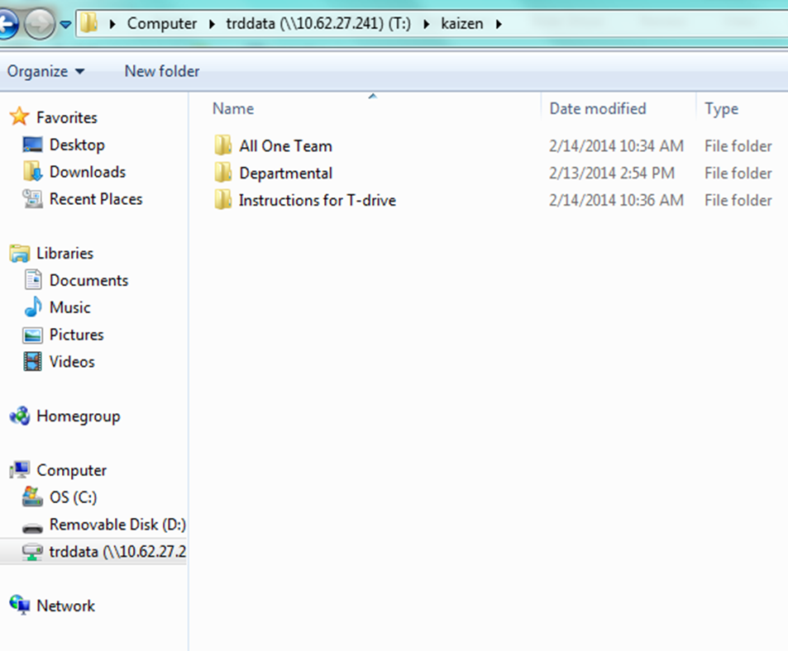

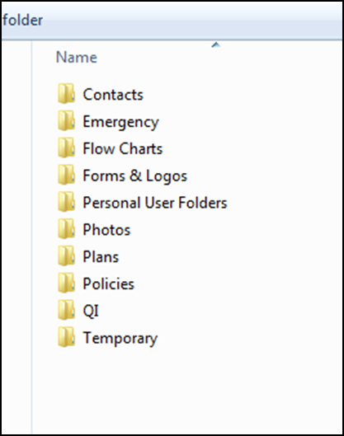 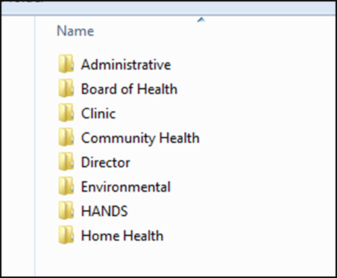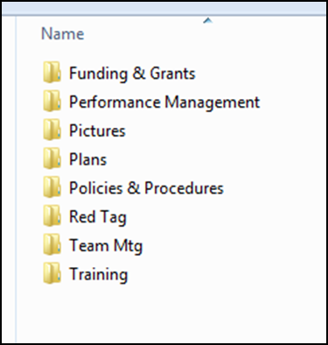

During the Kaizen event, the team developed several key action points that would enhance our new t-drive structure. First, establishing a document that encompassed all of the guidelines for the t-drive was created. Also, a policy was formed that would be implemented across the agency, voted on by our District Board of Health. Policies are reviewed annually by the TRDHD Management Team to ensure consistency. The training plan was developed so that each employee would receive training on the t-drive in a group and individual setting, which would allow for the general concept to be explained, and then hands-on demonstrations. Lastly, three members of the Kaizen team sit as active members on the TRDHD Quality Improvement team, where they give monthly updates on the project and any changes that have been made based on feedback.

Managers and supervisors were given 4 weeks to transfer their documents from the old t-drive to the new structure. The new t-drive would be able to “go live,” on April 4, 2014.

To maintain an avenue for staff to provide feedback on issues and solutions, a bulletin board at each site was established (see picture). To date (5.19.2014) only one post-it has been received. Kaizen team members will continue to monitor the bulletin boards and encourage staff to utilize these spaces for feedback.

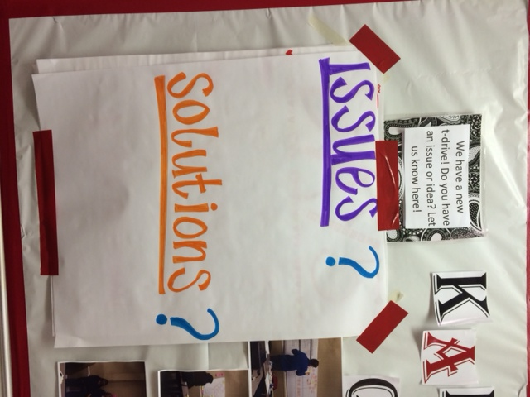

18. Measure Success attach graph/table of installed performance



|  |  |  |  |  |  |  |
| --- | --- | --- | --- | --- | --- | --- |
| **T-Drive Alive Staff Survey** |  |  |  |  |  |  |
|  | Before | | After | | Delta | **% Change** |
| Survey Date | 12/13/2013 | | 5/13/2013 | |  |  |
| Number of Respondents | 58 | | 57 | |  |  |
|  | Reponses | Percentage | Reponses | Percentage | |  |
| Do you know how to access the T-drive? |  |  |  |  |  |  |
| With someone's help | 5 | 8.6% | 5 | 8.8% | 0.2% | **2.3%** |
| No | 8 | 13.8% | 4 | 7.0% | -6.8% | **-49.3%** |
| Sometimes | 11 | 19.0% | 3 | 5.3% | -13.7% | **-72.1%** |
| Yes, always | 34 | 58.6% | 45 | 78.9% | 20.3% | **34.6%** |
|  |  |  |  |  |  |  |
| In a typical day, how often do you use the T-drive? | |  |  |  |  |  |
| Never | 21 | 36.2% | 19 | 33.3% | -2.9% | **-8.0%** |
| < once per day, several X per week | 24 | 41.4% | 20 | 35.1% | -6.3% | **-15.2%** |
| Once per day | 2 | 3.4% | 5 | 8.8% | 5.4% | **158.8%** |
| > once per day | 10 | 17.2% | 13 | 22.8% | 5.6% | **32.6%** |
| What is the T-drive? | 1 | 1.7% | 0 | 0.0% | -1.7% | **-100.0%** |
|  |  |  |  |  |  |  |
| What are the biggest barriers to limit T-drive use? Check all that apply. | | |  |  |  |  |
| Can't find what I'm looking for | 32 | 47.1% | 3 | 5.1% | -42.0% | **-89.2%** |
| Don't know how to get on T-drive | 7 | 10.3% | 4 | 6.8% | -3.5% | **-34.0%** |
| Don't know why I need to get on T-drive | 10 | 14.7% | 4 | 6.8% | -7.9% | **-53.7%** |
| Access is denied | 7 | 10.3% | 3 | 5.1% | -5.2% | **-50.5%** |
| Other | 12 | 17.6% | 4 | 6.8% | -10.8% | **-61.4%** |
| No barriers |  |  | 41 | 69.5% | 69.5% |  |
|  |  |  |  |  |  |  |
| How often are you unable to find something on the T-drive? | |  |  |  |  |  |
| Frequently | 18 | 31.0% | 9 | 15.8% | -15.2% | **-49.0%** |
| Sometimes | 31 | 53.4% | 18 | 31.6% | -21.8% | **-40.8%** |
| Never - I can always find what I'm looking for | 9 | 15.5% | 30 | 52.6% | 37.1% | **239.4%** |
|  |  |  |  |  |  |  |
| The new structure of the T-drive is (can choose multiple): | |  |  |  |  |  |
| More user-friendly |  |  | 45 | 37.2% |  |  |
| Faster to find items |  |  | 32 | 26.4% |  |  |
| Better organized |  |  | 39 | 32.2% |  |  |
| Not as user-friendly |  |  | 0 | 0.0% |  |  |
| Less organized |  |  | 0 | 0.0% |  |  |
| Harder to find items |  |  | 0 | 0.0% |  |  |
| Other |  |  | 5 | 4.1% |  |  |

