**Project Team:**  Department of Health in Seminole County, Streamlining the Requisition Process

**Timeline:**  Kaizen event January 13 – 17, 2014

_ SOLVE _

1. Starting Point

1. **What is the need (e.g. outcome) or gap that caused this project to be considered in the first place?**

The need of this project is to reduce the transactional cost of Goods/Service procured by the DOH-Seminole. By making a more streamline process and reducing the actual cost of Goods/Service per Purchase Order DOH-Seminole will be able to increase efficiencies and cost savings. Need to cut costs of items by $18,000 within 1 year and reduce actual process time needed per purchase order. For the purposes of this event we will focus in on our top three identified commodities, promotional, contract and items over $1,000.

**b. Who is establishing the need?**

**Finance Director/ Business Office.**

**c. How is the need being measured and is it possible for this project to make an impact on that measure?**  The measures utilized will include labor time associated with the requisition process, correct and complete order requests submitted by the program manager to the business office and business office to State office as well as overall costs per item purchased. Utilization of a Kaizen event will allow for identification of waste and financial efficiency gaps.

**d. What data or analysis was used to establish that this project will make a key impact?**

Spending Plan, L4 Budget Reports, MFMP Data Systems, Time Studies

**e. What scope (e.g. geographic, organization, customer) are you expected to impact?**

We expect to impact the Health Department Employees, Clients, and Taxpayers of Seminole County

**f. What conditions are being placed on this project?**

* My Florida Marketplace
* State Policies Florida Statues
* State Term Contracts

2. Vision **(**What do you want to achieve in the long range and without any restrictions? *Generate a picture or description of your ideal condition.* How will it look for the customers, our team, and for the taxpayers/funding sources?)

* My vision is to have a procurement process that will ensure that the good/service obtained are needed, quickly processed, and cost effective, ensuring sound fiscal accountability. With revenue decreasing and rising expense, we must ensure we can reduce the cost of doing business to the most efficient way.

**3.** Current State (Description of how the process and organization is operating now; Quantitative if possible, always factual and based on observation)

|  |  |  |
| --- | --- | --- |
| Stakeholder | Description | How do you know?  (Data if available) |
| Customers | * Internal Requestors- 25 * Business Office * Vendors | Request |
| Financial | * Finance Director- Reduced 200K and streamline the process | Spending Plan |
| Your Team | * Approved Requests * Started to do the Purchase Orders | Purchase Orders |

4. Goal or Target Condition(What is the objective? Which piece of the gap are you addressing?)

TO: Reduce the transactional cost of goods and services procured thru the MyFloridaMarketPlacesystem.

Transactional cost is defined as: actual monetary cost of item and employee time cost related to salary.

5. Customers and Beneficiaries (Who benefits from achieving the goal? What populations are targeted?)

* Clients of the Department of Health in Seminole County who rely on our operational availability
* Contracted State of Florida vendors who rely on timely notification of goods and payment for those goods
* State Office Representatives who must review and correct errors on submitted purchase orders
* Staff of the Department of Health in Seminole County who rely on the timely receipt of needed goods to provide services to our population

6. Benefit(What are the benefits from achieving the goal?)

SO THAT:

* More time can be spent on direct client services
* Consistency is obtained in the cost of goods
* Increased financial accountability and cost savings for the organization
* Purchasing structure that promotes cost savings and time efficiency

7. Measures and Targets (What quantitatively will be achieved?)

|  |  |  |  |  |  |
| --- | --- | --- | --- | --- | --- |
| Beneficiaries | What Measured | How Measured | Target | | |
| How Much | By When | Actual |
|  | Quality: Submitted order forms | % = correct & complete forms / submitted forms  -incorrect forms recorded by Michael & Mitzi (daily) -total forms captured by Udgit (monthly) | > 75% | May 1, 2014 |  |
|  | Quality: Submitted purchase requisition | % = correct & complete forms / submitted forms  -incorrect forms recorded by Tallahassee (monthly) -total forms captured by Udgit (monthly) | > 90% | May 1, 2014 |  |
|  | Cost: Reduced cost of purchased items | $ = negotiated savings when price is lower than preferred vendor recorded by Udgit (quarterly)  $ = when multiple quotes are obtained price is lower than preferred vendor recorded by purchaser (quarterly)  # = new negotiated vendors on the preferred vendor list (quarterly) | $4500 / qtr  5 new negotiated vendors/ qtr | May 1, 2014 |  |
|  | Time | Total employee labor time (Form completion to submission to State). 5 time studies completed monthly. | * 25% less time than January 2014 Waste Analysis estimation | March 1, 2014 |  |

8. Conditions(What do you need to be successful?)

* State policies regarding purchasing, limitations of system.

9. Team Members and Roles (Who is directly involved and How? Training Needs?)

|  |  |  |  |  |
| --- | --- | --- | --- | --- |
| Name | Role | Work process related interests / concerns | Project Expectations | Project, QI skills |
| Udgit Mehta | Process Owner | Finance Reduction | $40,000, employee time savings, review total process for $400,000 savings | Fishbone Analysis, Business Skills |
| Sara Warren | QI Leader | Oversight of event |  |  |
| Mike Farnes | Accountant II | Purchaser/ Budget |  |  |
| Mitzi Stone | Assistant | Purchaser |  |  |
| Diana Rice | Accountant II | Accounts Payable |  |  |
| Pranav Mehta | Staff Assistant | Wild Card |  |  |
|  |  |  |  |  |

*Training Needs:*

10. Project Schedule (Activities to go about solving the problem)

* By: What is the approach to the problem?
* High level activities:
* Prepare for kaizen; Perform kaizen; Institutionalize the change; Draft the detailed project schedule 

**11a.** **Data and Information Collection**(What will you collect? Who? When?)

|  |  |  |
| --- | --- | --- |
| **WHAT** | **WHO** | **WHEN** |
| PO Volume by category | Michael |  |
| PO spend by category | Michael |  |
| Tallahassee purchasing agent error reports | Udgit |  |
|  |  |  |

11b. Observe and Document Current Process (Generate a Process Map)

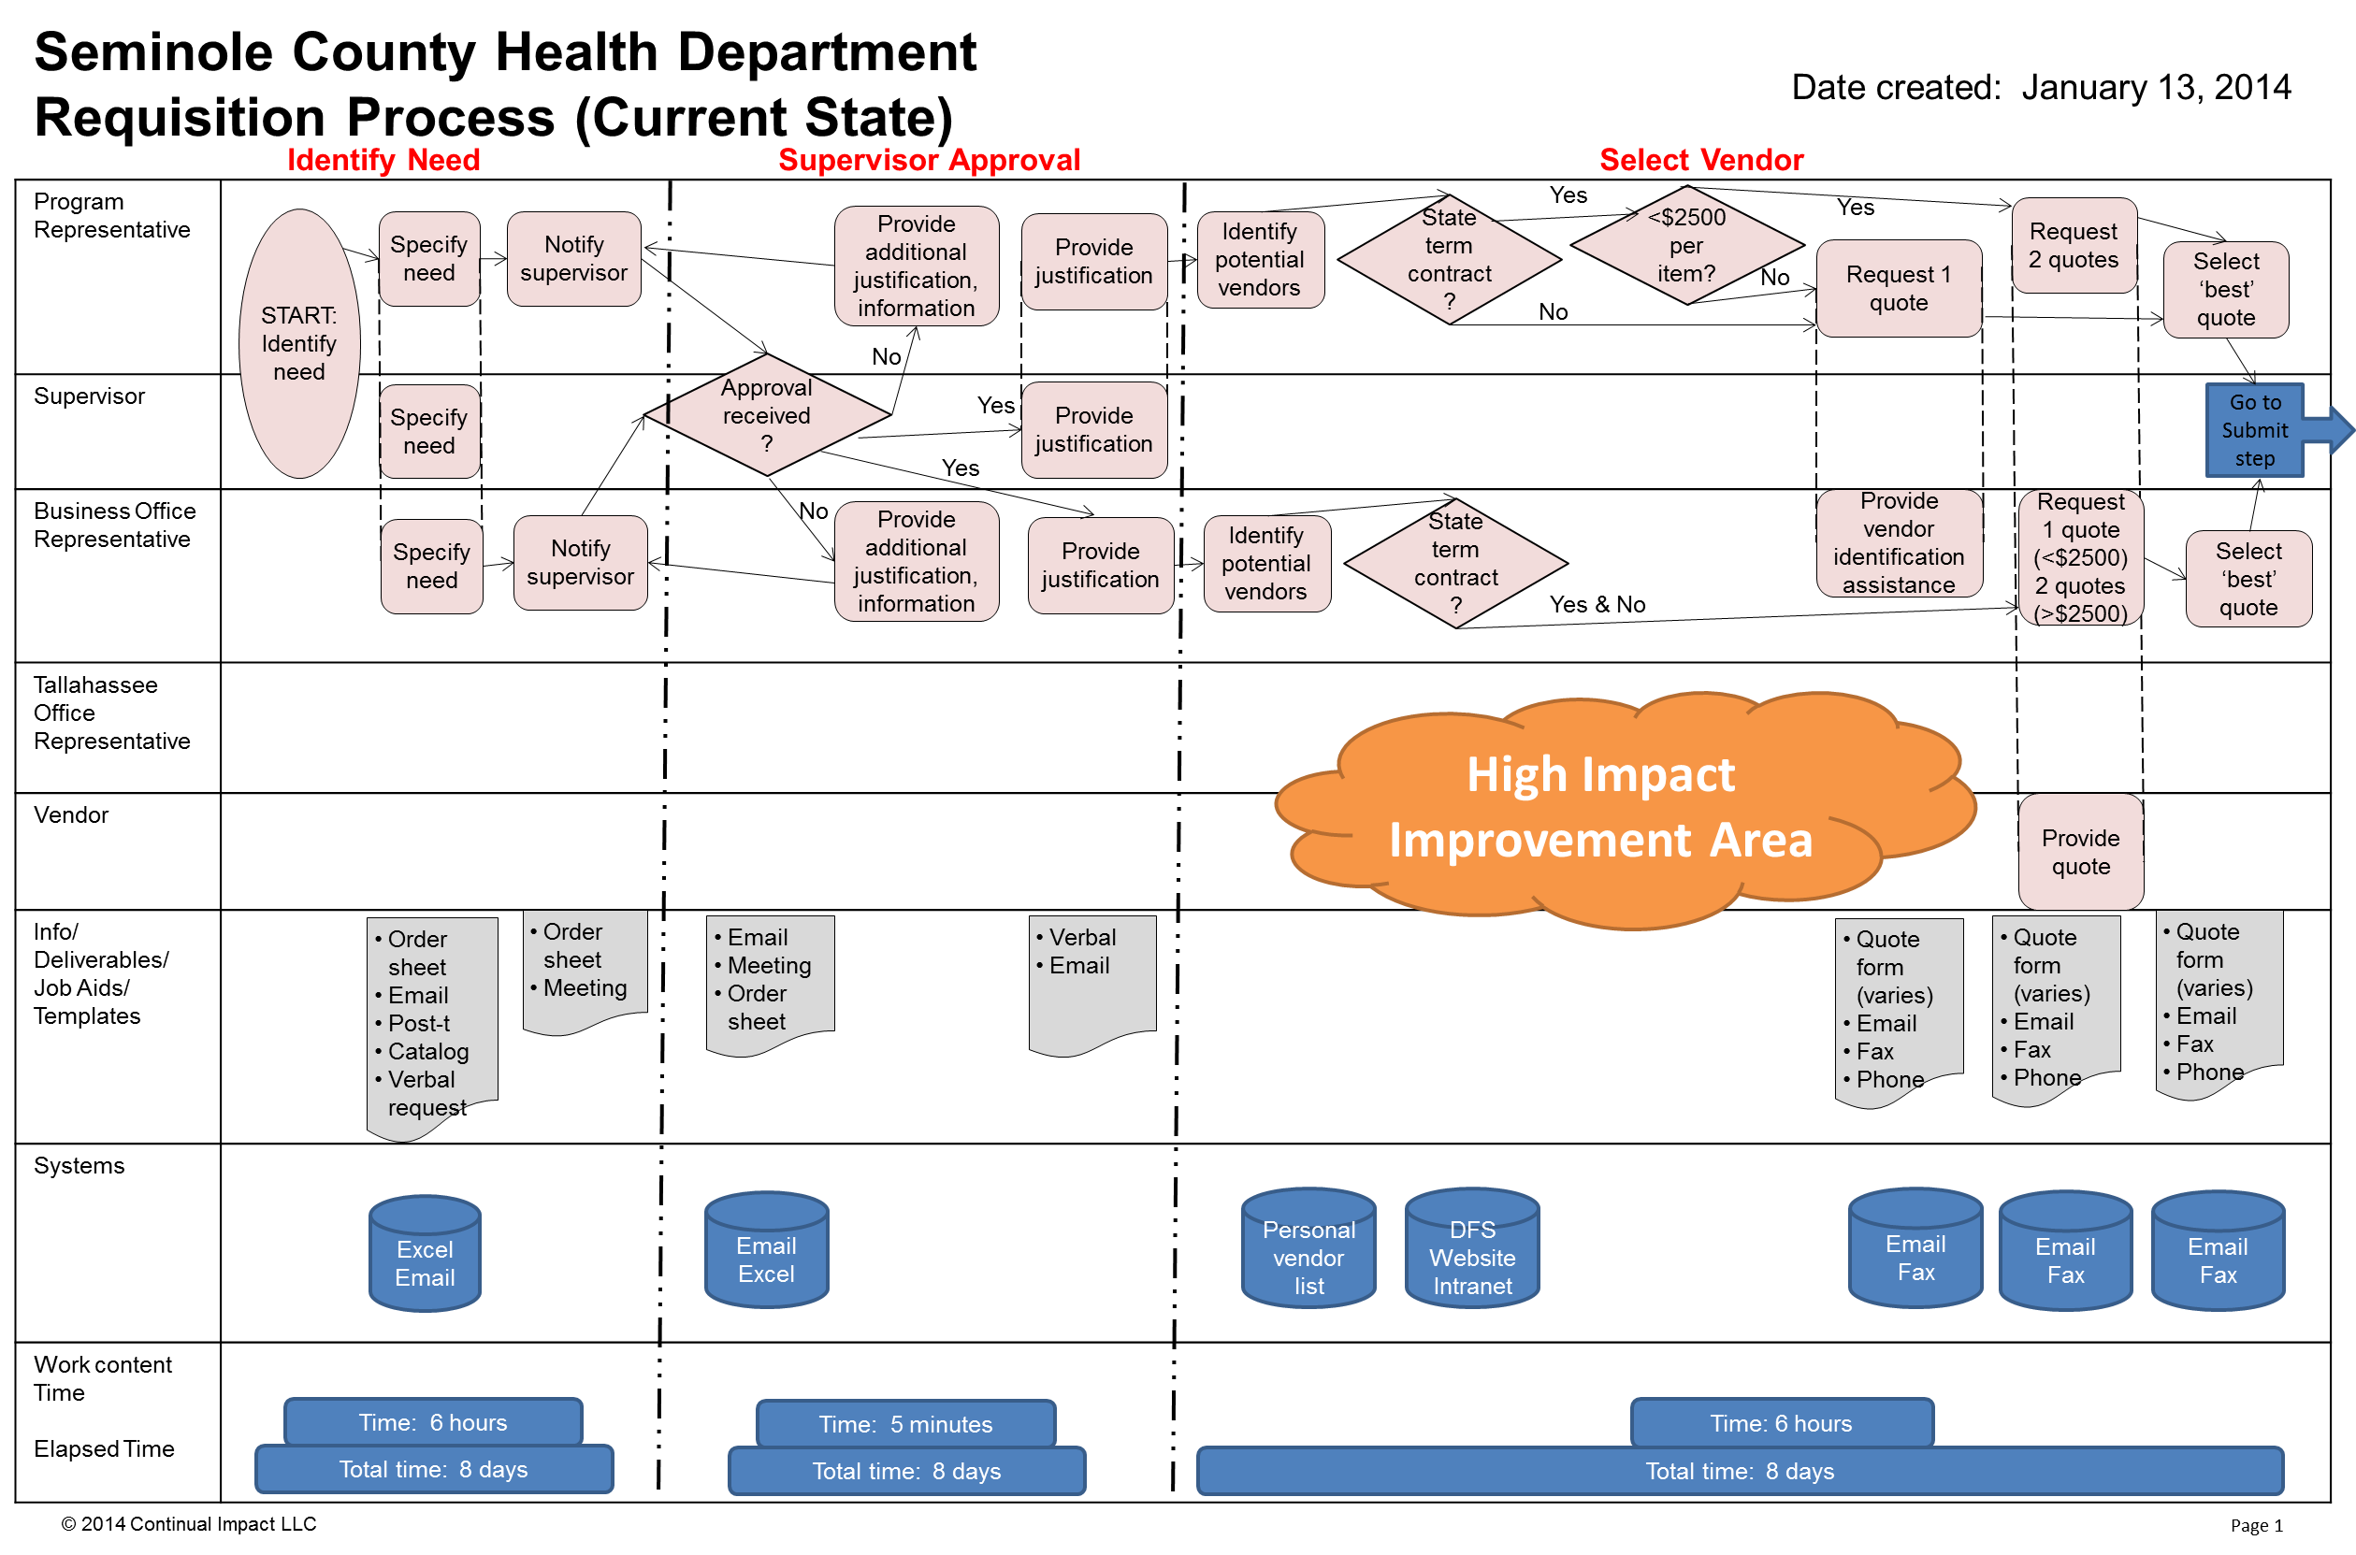

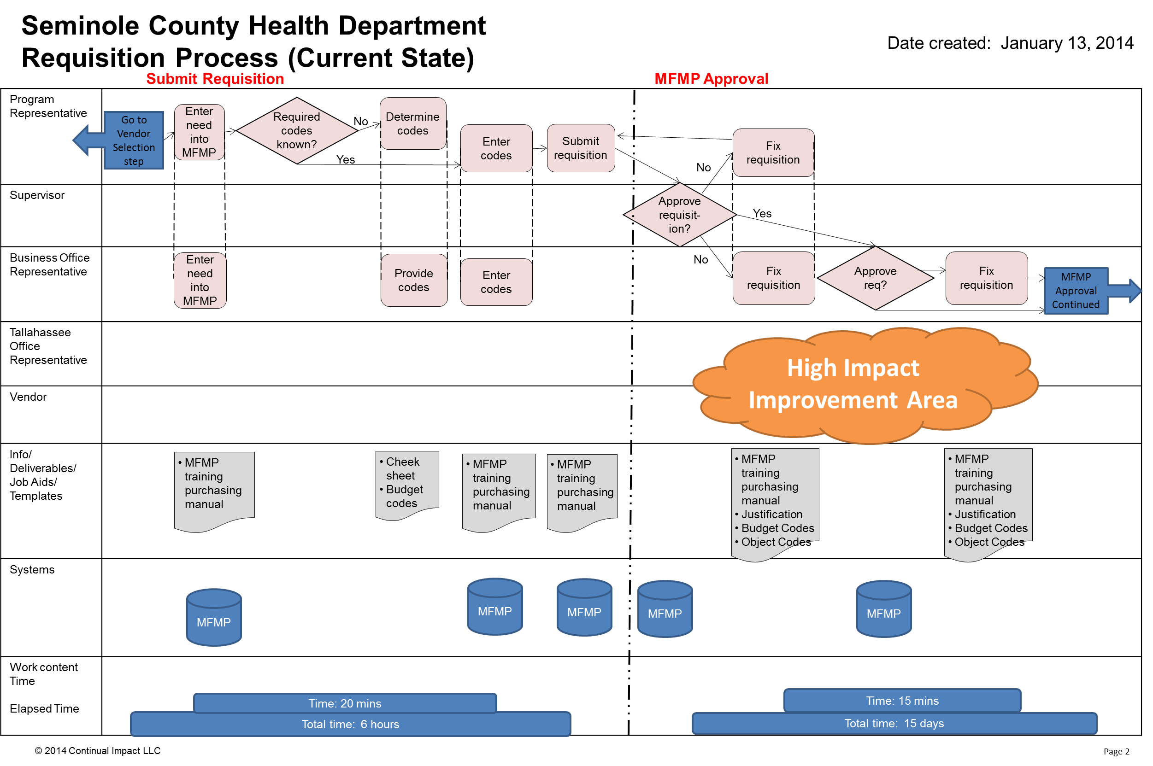

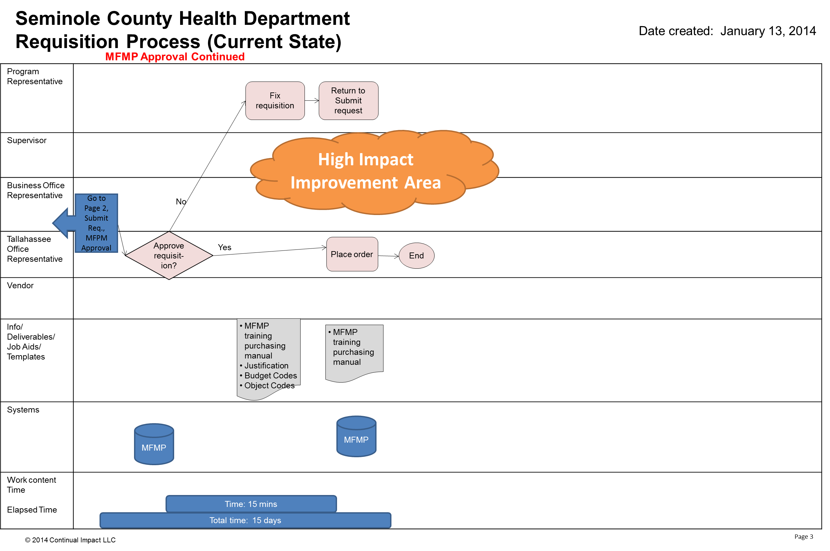

Issues prioritization

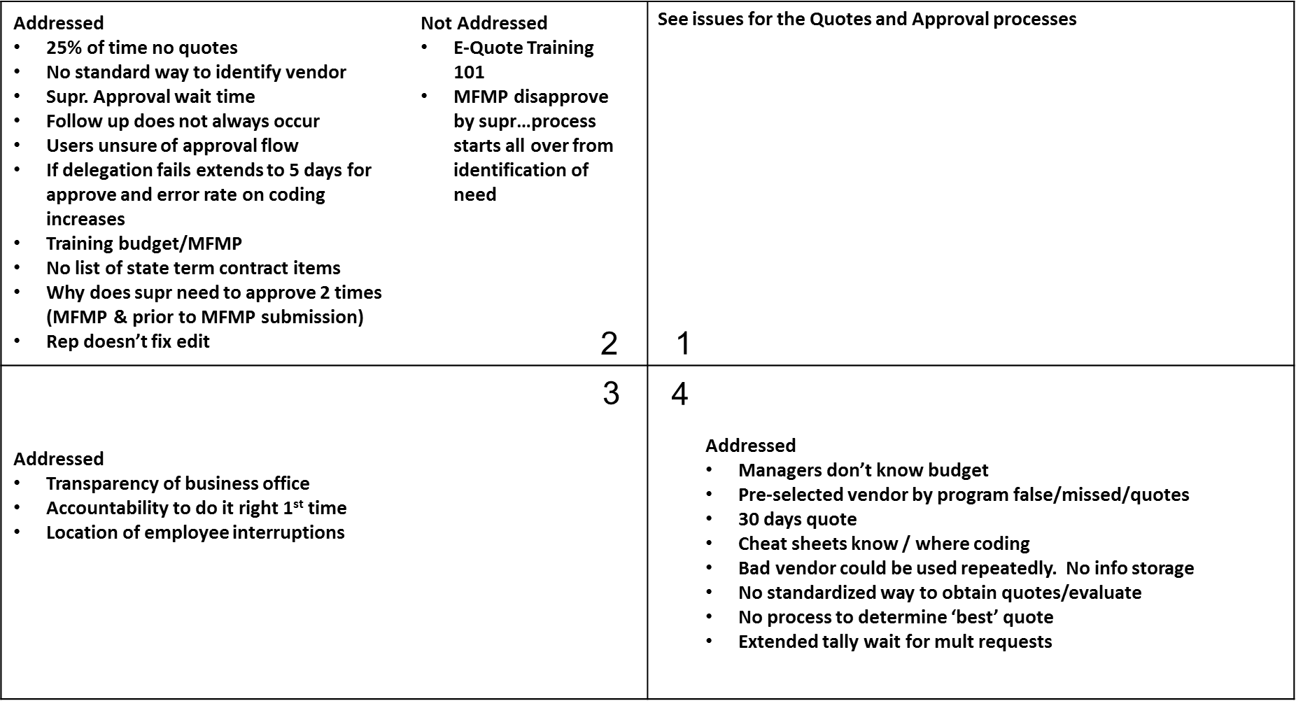

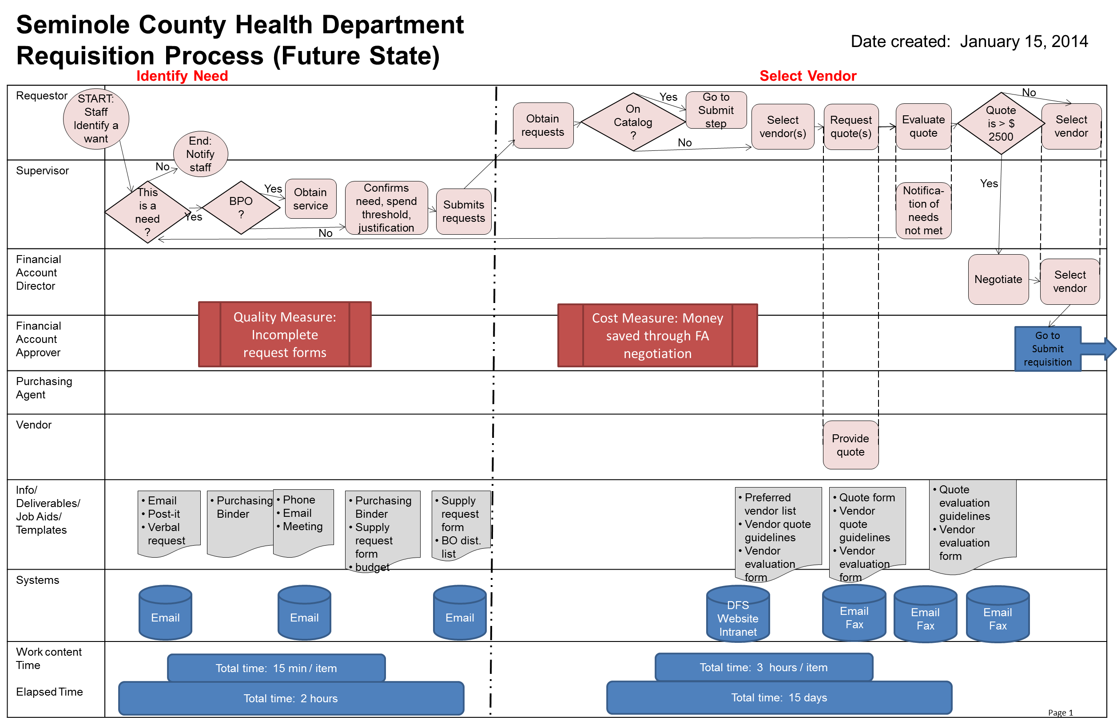

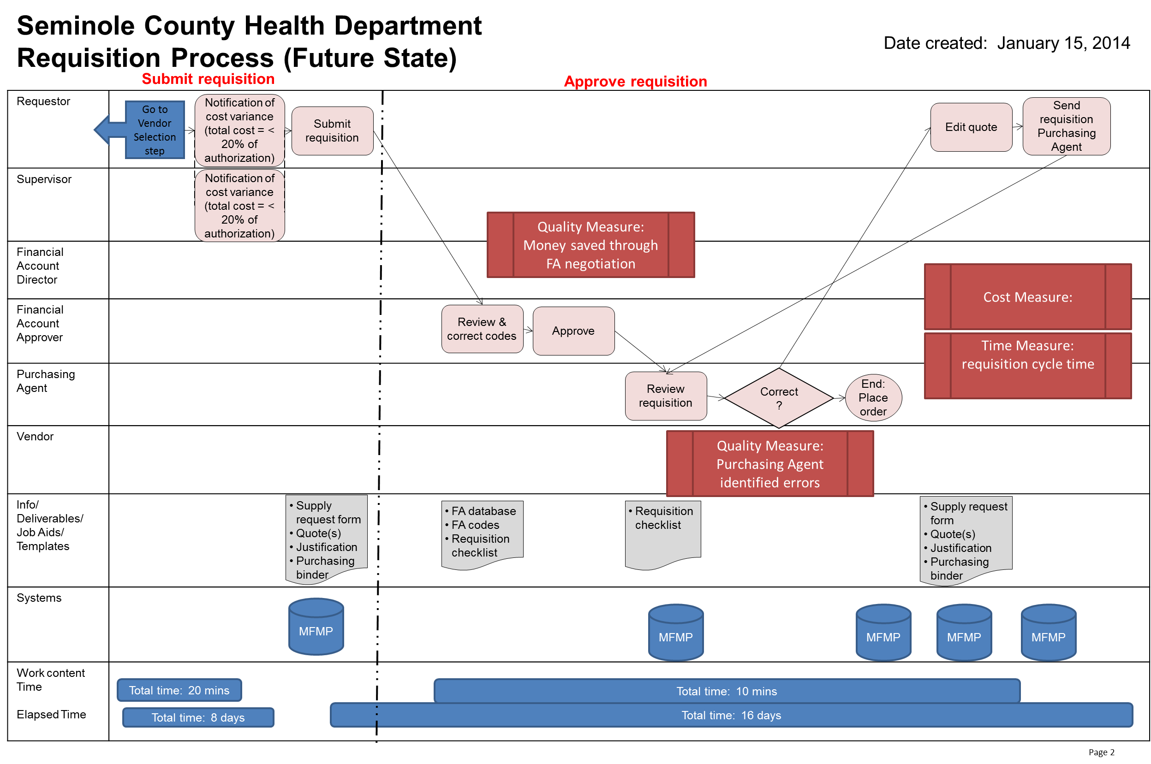

12. Conduct Cause and Effect Analysis(Priority issues and solutions from Cause and Effect Analysis)

|  |  |  |  |  |  |
| --- | --- | --- | --- | --- | --- |
| **Category** | **Issues/Wastes** | **Root Causes** | **Solutions or Additional CI Methods to use** | **Speed and Cost to Implement** | |
| Work Process | Waiting, searching, inspection and rework exist in current process  Role clarity and standardized work gaps exist | * Reliable process does not exist * Standardized work and job aids not readily available and understood * Measures of performance not tracked * Process understanding and training gaps exist * Accountabilities for use not clear and trusted; multiple approval steps apparent * Historic budget accountability concerns | Create an improved (effective and efficient) process particularly in obtaining quotes and approval of the selection that reduces wastes (overlapping tasks, rework) including job aids, measures and clear accountability  Operationalize and roll out process effectively including training, measurement and accountability for use. | One week Kaizen event, training and follow-up time |
| Purchased cost of OCO, Promotions and Services | Gaps exist in obtaining and evaluating quotes, negotiating prices in order to provide cost reduction | Decision making criteria for quoting requirements and evaluating quotes not available.  Accountability for negotiating not clear.  Preferred suppliers not identified and available for convenient use. | Provide decision making guidance as part of above process changes and job aids  Create and make available preferred supplier list based on quality and competitiveness  Implement new policies for obtaining, evaluating and negotiating quotes | One week Kaizen event, training and follow-up time | |

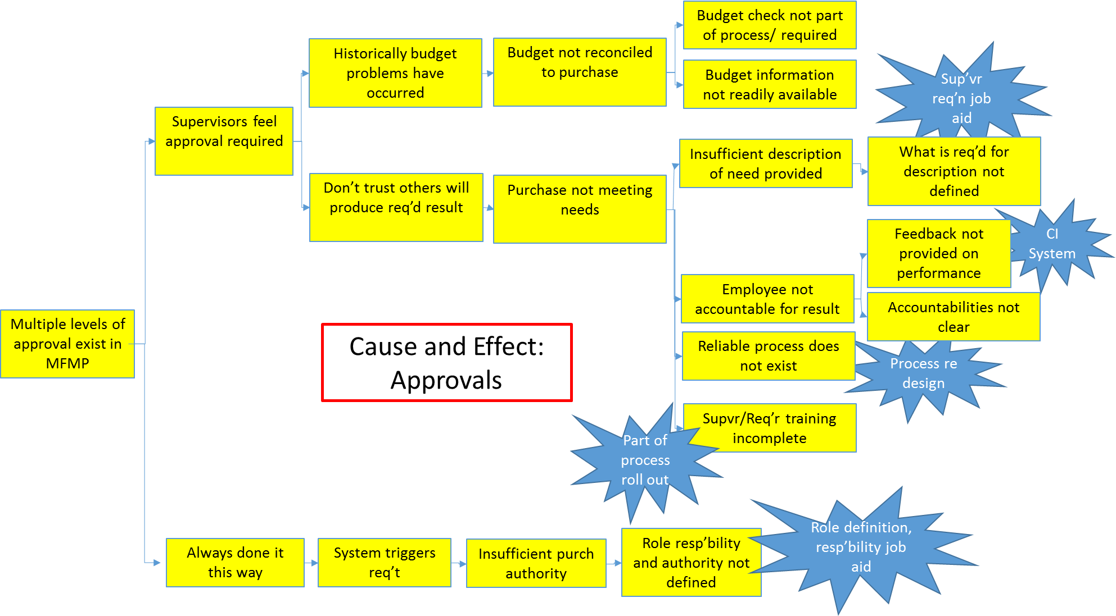

13. Improvement Hypothesis **(**Summary of potential means to achieve goal)

|  |  |  |
| --- | --- | --- |
| **Issue** | **Improvement** | **Expected Results** |
| Work process | If we redesign the process to eliminate wastes and redundancies (particularly in the quoting and approval areas), provide reference information for completing tasks, decision making guidelines and job aids to help identify needed and correct information… | … then defects and rework loops will be reduced and overall labor time required (employee time) to complete the process will be reduced |
| Cost reduction opportunities in purchased goods and services | If we identify preferred suppliers (quality and price) for requisitioners to use, obtain multiple quotes for comparisons, and negotiate as appropriate as part of an integrated and consistent work process… | …then, procured costs for OCO, promotions and services will decrease as measured by cumulative savings identified by requisitioners and the business area |
| Work process | If we identify one method of supply/service request…. | …. then a standardized approach to purchasing will be established |

_ TRY _

14. Test Hypotheses **(**How will you test the potential solutions?)

|  |  |  |  |  |
| --- | --- | --- | --- | --- |
| **Tests** | **How** | **When** | **Who** | **Successful if…** |
| Identify Need Process & Job Aid test | Provide instructions on Id Need process, request form, justification, binder material  Complete the form, record time & questions, solicit feedback | Thursday/ Ongoing per CIS | Udgit | Form is clear, clean, complete. |
| Preferred vendor list | X# Supervisors  Provide instructions & list  Id missing / not recommended vendors | Thursday/ Ongoing per CIS | Business Office | List has >90% of vendors for all program areas |
| **Select Vendor** process & job aid test | Provide instructions on process, vendor list, quote form, quote guidelines, evaluation guidelines, form to capture savings  Complete the form, record time & questions, solicit feedback | Thursday/ Ongoing per CIS | Business Office | Form is clear, clean, complete |
| End to end test | Perform this test for 1. OCO, 2. Services, 3. Promotions  Identify program areas  Provide instructions on process, **Identify need** (binder, form) & **select vendor** (vendor list, quote form, quote guidelines, evaluation guidelines) job aids  FA Approver review | Thursday/ Ongoing per CIS | Udgit, Sara, Parnav | Follow process  Code, form accuracy  Captured modifications to the process map |

15. Results: attach graph/table of actual trial performance

Request Form tests results:

* Joyce entered a service order using the new request form.
* Share site was not working on Joyce’s PC
* She mentioned that It is similar to the current form, but the links (when they work will be beneficial
* She requested that all coding be automatically populated when she enters her name in as requestor.
* She requested a hyperlink to Business Office distribution list from form.
* She felt once changes made to the form, she will be able to complete and email in a quicker fashion then the current process.
* She would like a list of most commonly ordered office supplies, restricting what can be ordered based possibly off cost (i.e. limit it to three-four pen types, not open).
* Excited about new process, feels that overall time will be saved.

Preferred Vendor List:

* Shared the draft list with 4 requestors
* Requestors provided additional adds/removes
* Revised format to increase ease of information verification

_ LEARN _

16. Learning (For the trials, what worked and did not, why and what are you doing as a result? Is the result repeatable?)

|  |  |  |
| --- | --- | --- |
| **Reasons** | **Learning: Why?** | **Direction: Actions to be taken** |
| Request Form:  +form is simpler  +form has links to codes  +form has references to other required info (BPO, justification)  -entering in the codes with separate boxes is clunky  +More structured  -Supr may delegate to requestor | * Errors can still be made in the request form * We still have 4 different request forms | Modify the code input section for easier entry – obtain IT assistance  Modify the form to cover supplies and services |
| Preferred Vendor List:  +add vendor email, vendor contact email, STC (Y/N), catalog (Y/N) | * Programs have some preferred vendors recorded in their own area | Requested list input from 4 program areas |
| End to End review of current process to identify waiste  Requestor training on a routine basis/incorporate into annual budget review. Ensure new hire training on practice.  Ensuring monthly updates provided to management staff to obtain by-in and support.  QI/Project support by staff to ensure understanding and support.  Sharepoint, ensure information provided from event is located on sharepoint. Information is easy to obtain, easy to understand, well documented for staff and accreditation needs. | * We have the potential to save time for the requestor and approvers   Ensure understanding by requestors of process, provide update information and reduce error rate.  Support needed to ensure process is maintained and that a pool of requestors is available to verify process and time study when needed.  Support needed so frequency of questions/calls decreases allowing for better time efficiency.  Increase understanding, ease of information availability, accreditation purposes, training purposes | Generation of process map, review with team on a quarterly basis to ensure appropriate/accurate steps are identified. Review waist areas and CIS out how to resolve.  Add process to required annual budget training.  Business office to prepare documentation on updates as needed.  Have as a standing MAC agenda item with project lead and contact point.  Ensure time at quarterly townhall to present on current project practices.  Monthly update by Business office for next 12 months regarding posted project information to Sharepoint site. |

_ INSTALL _ 17. Installation Plan  (Steps to operationalize the new process and make it stick.)

* **Conduction of monthly update meetings, during scheduled management meeting to review project measures and current state. To be completed July 2014.**



18. Measure Success

**Process Time Study Outcomes Measure 4**

**Goal: Process time reduction of 25%.**



**Cost Reductions Measure 3**

**Goal: Savings of $4,500 per quarter based off price negotiations.**

**Quality Requisitions to State Office Measure 2**

**Goal: 90% Submitted Requisitions Approved**

**Quality Order Forms to Business Office Measure 1**

**Goal: 75% Order Forms Completed/Submitted Correctly**