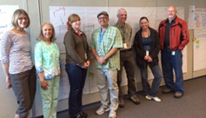
The following action plan was developed on the second day of the Food Safety & Health Equity Kaizen event that took place 4/29 and 4/30 with all Food Safety program staff participating.
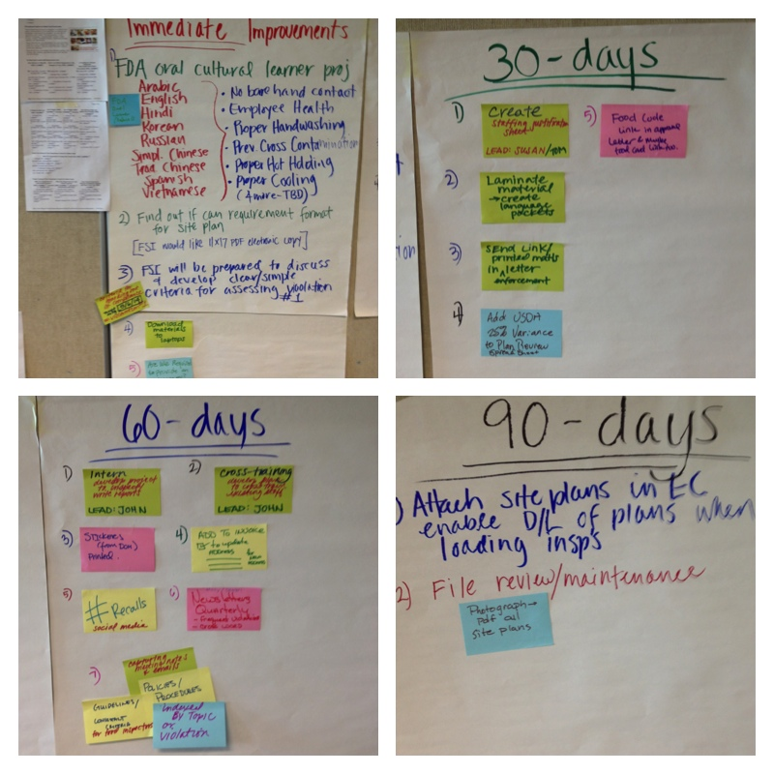
IMMEDIATE IMPROVEMENTS:
- Begin to use resources from the FDA Oral Culture Learner Project: (see next page).
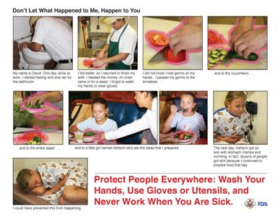
- These posters/storyboards are designed to enhance food safety training efforts at the retail level by helping food employees understand the important role they play in protecting public health. They are available in nine different languages, including Arabic, English, Hindi, Korean, Russian, Simplified Chinese, Traditional Chinese, Spanish, and Vietnamese.
- These materials are not copyrighted. You may post these materials on your website and distribute them freely. We kindly ask, however, that you credit FDA when using or posting the materials.
The only languages that are missing for Whatcom County are Punjabi and Thai, although we will be researching if Punjabi food establishments can read Hindi. [Susan]
The following posters are available in these nine languages:
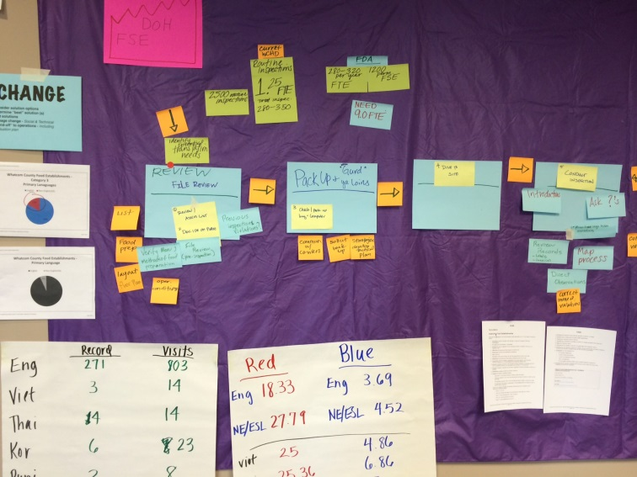
- No Bare Hand Contact with Ready-to-Eat Food
- Employee Health
- Proper Handwashing
- Prevention of Cross-Contamination
- Proper Hot Holding of Time-Temperature Control for Safety Foods
- Proper Cooling of Time-Temperature Control for Safety Foods
Addition topics that will soon be available include:
- Proper Cooking
- Proper Cold Holding and Date Marking of Time-Temperature Control for Safety Foods
- Approved Food Sources
- Proper Use and Storage of Chemicals
NOTE: Average (mean) red violation points per inspection: 18.33 (English) 27.79 (non-English)
- The team will research if there is a required scale for the food establishment site plan. Food Safety Inspectors would like an 11 x 17 copy to review before site inspections.
- Food Safety Inspectors will be prepared to discuss and develop clear/simple criteria for assessing violation #1 (not currently being assessed).
- Download all pertinent materials to laptops (site plan, menus, past inspection reports, etc.)
- Research: Are we required to provide translation for food establishment operators? [John] 50% of food establishment operators who were interviewed (n=16) stated that language was a barrier to compliance.
30-DAY IMPROVEMENTS:
- Create fact sheet supporting the need for new staff. [Lead: Susan/Tom]. Over the course of the Kaizen it was universally agreed that 1.5 FTE to inspect some 1,200 food establishments is inadequate even with substantial improvements to the food inspection process.
- Laminate FDA materials and create language packets for use in the field.
- Send link to FDA materials in enforcement letters.
- Add USDA 25% variance to plan review spreadsheet?????
- Provide Food Code link in food establishment approval letter and maybe to workers with a food card.
60-DAY IMPROVEMENTS:
- Develop an intern project to increase capacity. [Lead: John]
- Develop plan to cross-train existing staff. [Lead: John]
- Print DOH stickers on basic food safety.
- Add a space on invoices to ask food establishments to update operator information.
- Use social media to post recall notices.
- Publish quarterly newsletter providing prevention information for frequent violations and food code updates.
- Capture Food Safety Program meeting notes and email content (to add to Sarah’s compendium).
90-DAY IMPROVEMENT
- Attach site plan in Envision Connect; enable download of plans when loading inspections.
- File review/maintenance; include photograph/pdf of all site plans.
OTHER INFORMATION & EVENT PHOTOS:
