OMC WTI Manual

This OMC Technical Manual is written for operating Oregon MothersCare WTI (Web-based Tracking Interface) system, referred to as Witty), provides details about the WTI screens, and how to conduct certain functions. WTI is web-based; as data is entered, it becomes immediately accessible to the State OMC Office. Security measures are in place to protect the confidentiality and privacy of our OMC clients.

Please review this manual prior to operating WTI, and keep it accessible as you learn the system. All OMC staff should keep a copy of this manual near their computers for use in entering data. In addition, a detailed description of all data and information fields is provided at the end of this document. Use this as a guide for any questions about the meaning of a certain field.

For questions about this document, or the WTI system, contact the Oregon MothersCare State Office at: 971-673-2306

How to access OMC online

To access the Oregon MothersCare Web-based Tracking Implementation (OMC WTI) database you must have an account login and password. After watching the OMC training video, you’ll be asked to take a short survey. When you complete the survey and return the signed OMC Confidentiality Statement by fax/mail you’ll receive your Account Name & Password by email. If you need a password reset, please call OMC at 971-673-2306.

- To login, open your internet browser and enter the following URL into the web address field, https://epi.state.or.us/fmi/iwp/res/iwp_home.html (Internet Explorer is preferred)

- A list of databases will appear. Click on “Oregon MothersCare”

- Enter your “Account Name and Password”, then click “Login”
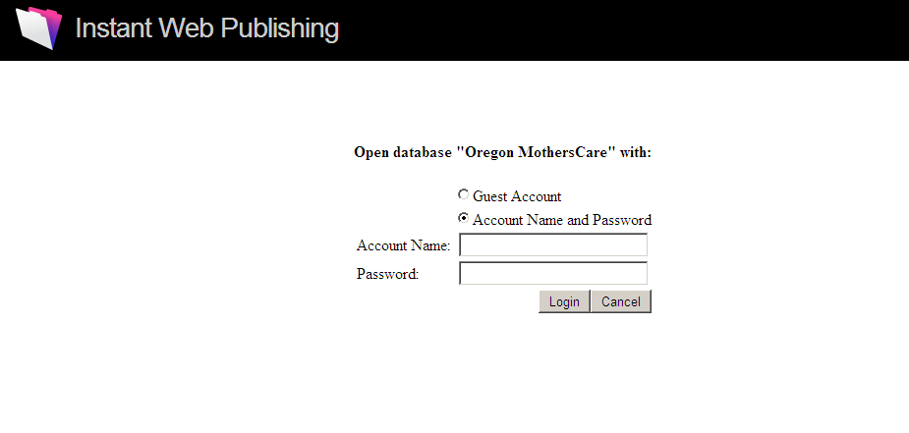

- After you logon, the Oregon MothersCare Home menu screen will appear. You can return to the Home menu from any screen by clicking on the Home icon.

Home screen
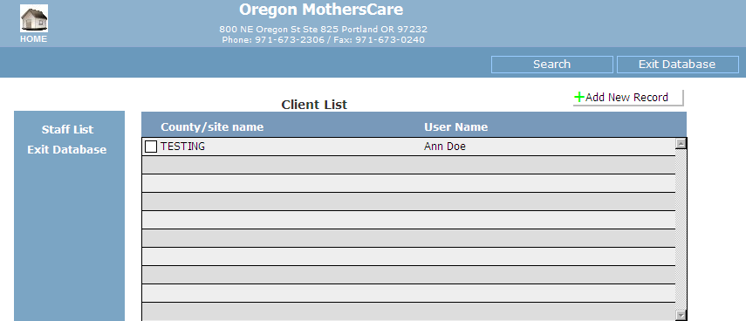

- The Home menu allows you to perform the following functions within the system:
- View the Staff List
- View the Client List
- Add a New Record
- Search for a client
- Exit the database

- To view the Staff List, click on“Staff List” on the left side and it will take you to the Staff List screen.

- This gives you a list of all the authorized OMC users at your site.

Staff List screen
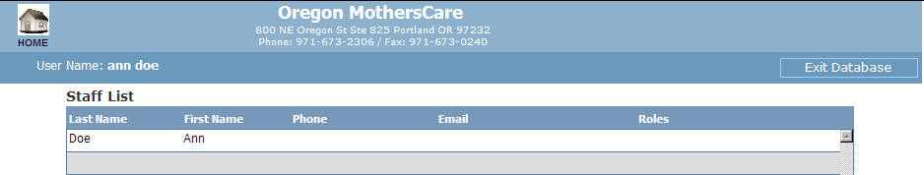

- To view the “Client List”, click on the small box next to your site’s name.

- It will take you to the Client List (below). If you want to modify an existing client’s record, click on the small box next to the Record ID. It will take you to the client’s tracking form so you can view or edit the record. Be sure to “Save Changes” to submit any editing. You can also add a new record from this screen. When you’re editing a record and need to change or delete the info you selected from a drop-down list, select the blank line at the bottom of the drop-down list.

Client List screen
- You can sort the Client List by clicking on the column headings.

- If you have not found your client in the Client List, you can do a search for the client. Select the “Search” button to search by
- Client ID (that’s the unique number that the system automatically generates for every record)
- Client name (you can enter in either the first or last name or both)
- Date of birth
- Date of initial contact (the date the client first contacted OMC)

Search for client screen
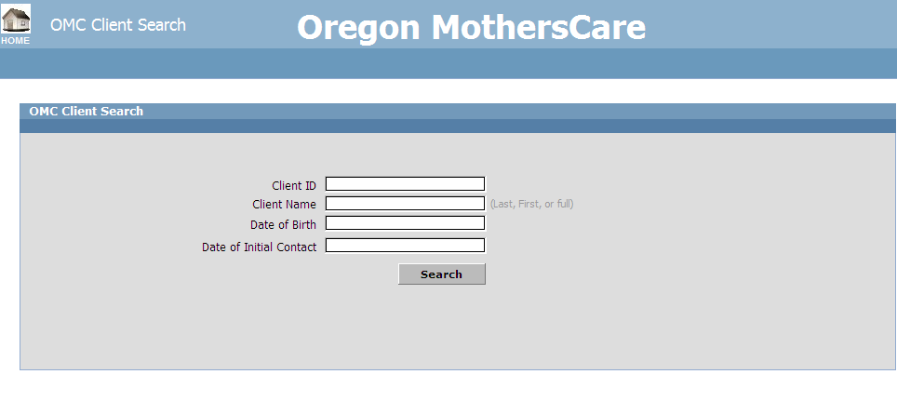

- To add a new client’s record, click on . A blank Client Tracking form will appear. The program will automatically fill in the “Record ID”.

- The fields with a green asterisk * by them are fields that are not reported or tracked by OMC. They are for your own use.

Blank Client Tracking form screen
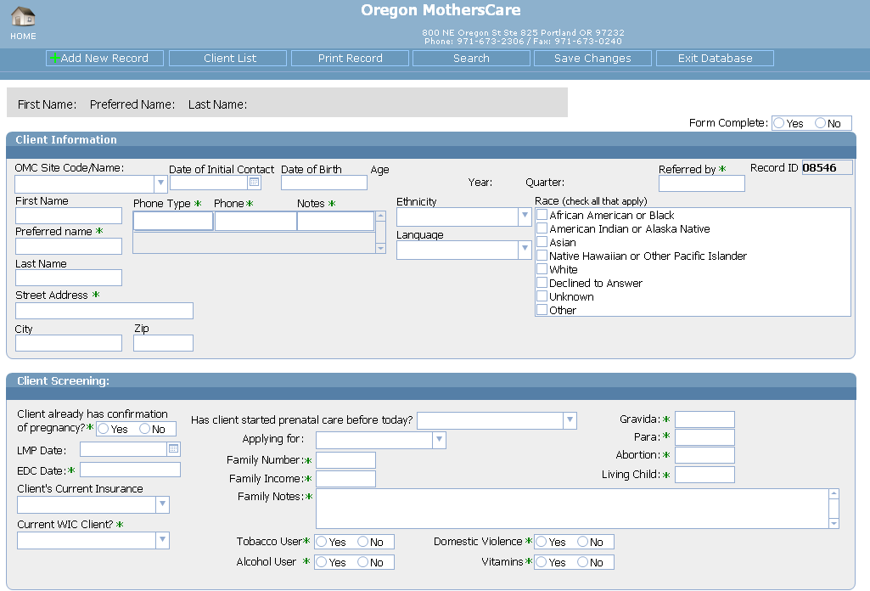
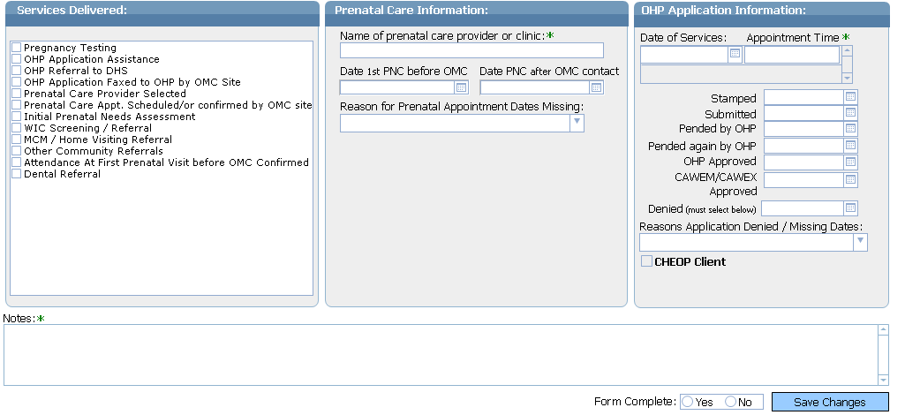

- Start data entry in the “OMC Site Code/Name” field. Click on the drop-down and select your site, immediately “Save Changes” after selecting your site. Without saving your site code, the system doesn’t know what site the record belongs to. It is now available only in the OMC State office database. If this happens to you, please call our office (971-673-2306) and we can assign the record to your site or delete it if necessary. The same is true if you create a new record by mistake.
- Please note that since you’re logging in through the internet, for security reasons your access through the web is only valid for an hour at a time. Because of that “Save Changes” often, before being locked out of the system. If you’re locked out, you can log back in and receive another hour.
- When you have completed entering all of the required fields, select “Yes” on “Form Complete”. You’ll be able to view on the Client List what records have not been completed, and return to them to complete. If you have not filled in ALL of the required fields select “No”. Again, you’ll be able to view a list of all the records that still need information. On the next page is a list of the State OMC required fields.

State OMC Required fields
OMC Site/Code Name | Date of Initial Contact | DOB | First & Last Name
City & Zip | Ethnicity | Language | Race
LMP Date | Client's Current Insurance | Has client already started PNC? | Applying for
Services Delivered | If client already started PNC before OMC, must have Date 1st PNC | Date PNC after OMC contact, if dates missing need reason selected | Date of Services
Stamped | Submitted | Approved or Denied, if denied, need reason | CHEOP Client, if applies to your site

- There are two ways to exit the database. However, before you exit the system, always remember to click on “Save Changes” to save any changes you have made to an existing or new client record that you created. To exit you can:
  - Click on “Exit Database” from any screen or,
  - Click on the at the top right-hand corner of the internet browser.
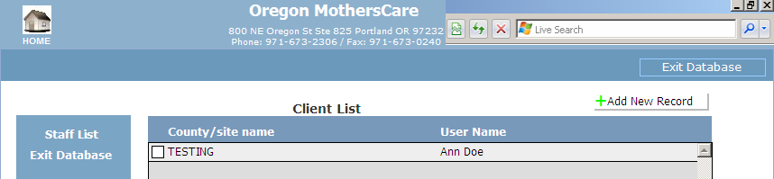

Client Record screen image
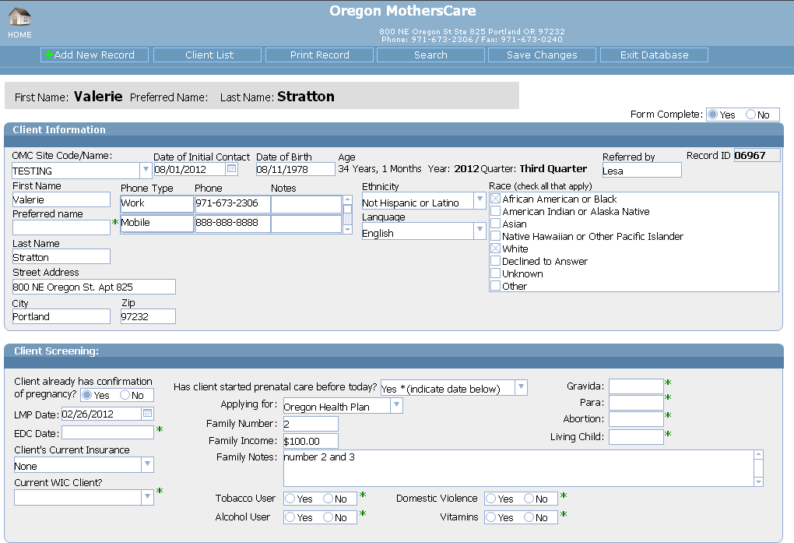
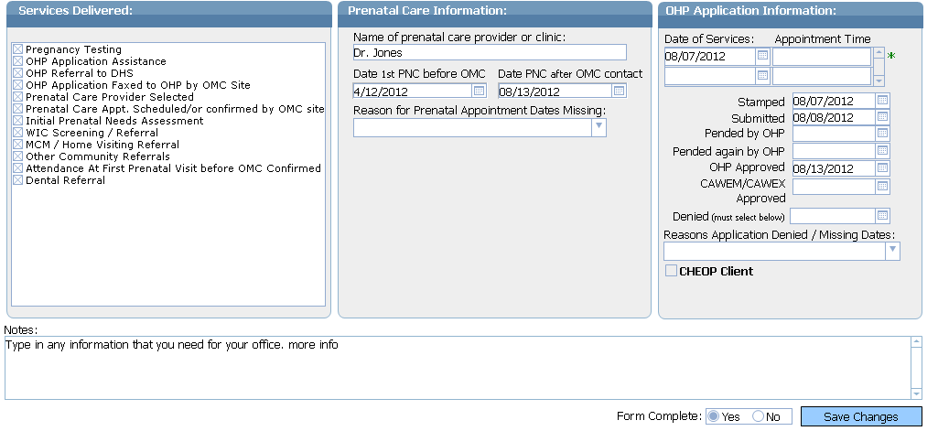

- If you need a paper copy of the client’s tracking form, select the “Print Record” button at the top of the record you’re viewing.
Screen shot of a printed record
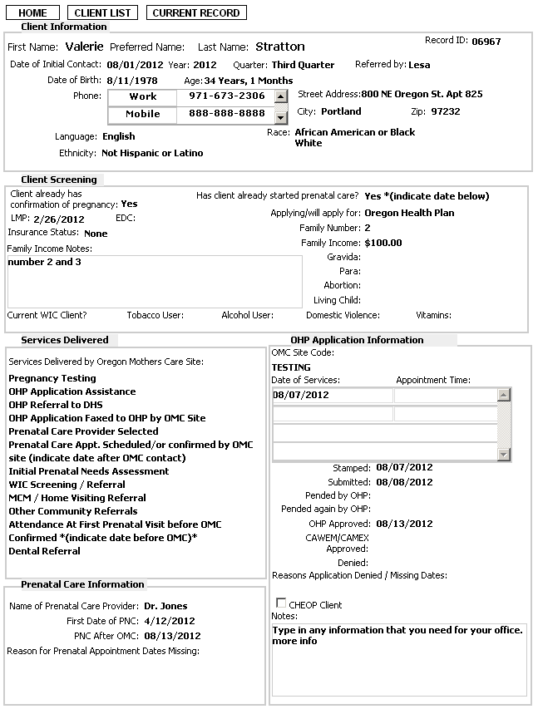
Search Function

Client ID | If you know the client’s ID #, you can search for the client by entering that unique #. The client ID # is automatically added when the record is created. You do not need to enter in the preceding 0.  Example:  - 08692  - 09967
Client Name | You can search for a client by name. You can enter their last name, first name or a combination of first and last name in any order. You may also use partial name as long as the characters entered are the first letters or the name.  Examples:  - An  - Ann  - An Smi  - An Smith  - Smi  - Smith Ann
DOB | You can search for client by DOB (Date of Birth). You can use this field by itself or in conjunction with other search criteria to narrow your search.  Example:  - Single date: 01/01/2012  - Less than date: <01/01/2012 (gives you all births prior to 01/01/2012).  - Greater than date: >01/01/2012 (gives you all births after 01/01/2012).  - Range of dates: 01/01/2012…03/31/2012 (gives you all births between 01/01/2012 and 03/31/2012).

Date of initial Contact | You can search for client Date of initial contact. You can use this field by itself or in conjunction with other search criteria to narrow your search.  Example:  Single date: 01/01/2012  - Less than date: <01/01/2012 (gives you all records created prior to 01/01/2012).  - Greater than date: >01/01/2012 (gives you all records created after 01/01/2012).  - Range of dates: 01/01/2012…03/31/2012 (gives you all records created between 01/01/2012 and 03/31/2012).

Detailed Field/Button Descriptions

Field/Button | DESCRIPTION
Home Icon | Click on this icon to go back to the Home screen menu.
Staff List | Click on “Staff List” to view all of the OMC authorized users at your site.
Client List (from Home screen) | Click on the white box next to your county to view the list of clients that are already in the database.
Add New Record | Click on this button to create a new client record.
Client List (top row tab) | Click on this button to view the “Client List” for your site.
Print Record | Click on to print the current record displayed.
Search | Click on to search for a client that was already entered into the database for your site. (see detailed instructions on how to use the Search function at the end of this document)
Save Changes | Click on this button to save changes you’ve made while editing or creating a client’s record. Any changes you’ve made to a record will not be recorded until you “Save Changes”. Use this button frequently.
Exit Database | Click on to exit the database.

Field/Button | DESCRIPTION
Form Complete | Select Yes only if all of the State OMC required fields are filled in. If they’re not completely filled in select No. You can sort by Yes or No on the “Client List” to easily pull up all of the records that need to be completed for your site.
OMC Site Code / Name | Select your OMC site from the drop-down list.
Date of Initial Contact | The date the client first contacted OMC by phone or in person. You can manually type it in or click on the calendar and select from there.
Date of Birth | The client’s date of birth. Date format is MM/DD/YYYY.
Age | This is tabulated automatically when you select “Save Changes”.
Year | This is tabulated automatically when you select “Save Changes”.
Quarter | This is tabulated automatically when you select “Save Changes”.
Referred by* | Not recorded or reported by OMC. For local OMC site use only.
Record ID | Unique identification number for the client. This number is system generated by OMC.
First Name | The client’s full legal first name.
Preferred Name* | What the client wants to be referred to by.  Not recorded or reported by OMC. For local OMC site use only.
Last Name | The client’s full legal last name.
Street Address* | Not recorded or reported by OMC. For local OMC site use only.
City | Where the client resides.
Zip | Where the client resides
Phone type* | Use the drop-down to select the type of phone. Home, Work, Cell, Message, Other, Primary or Secondary.  Not recorded or reported by OMC. For local OMC site use only.
Phone* | Manually type in the number. The dashes will appear when you “Save Changes”.  Not recorded or reported by OMC. For local OMC site use only.
Notes* | Not recorded or reported by OMC. For local OMC site use only.
Phone type* | You can enter in a second number.  Not recorded or reported by OMC. For local OMC site use only.
Phone* | You can enter in a second number.  Not recorded or reported by OMC. For local OMC site use only.
Notes* | Not recorded or reported by OMC. For local OMC site use only.

Field/Button | DESCRIPTION
Ethnicity | Select from the drop-down. Hispanic or Latino, Not Hispanic or Latino, Declined to Answer or Unknown.
Language | Select from the drop-down. The client’s primary or preferred spoken language. English, Cantonese, Spanish, Russian, Vietnamese or Other.
Race | Check as many as apply. African American or Black, American Indian or Alaska Native, Asian, Native Hawaiian or Other Pacific Islander, White, Declined to Answer, Unknown or Other.
Client already has confirmation of pregnancy?* | Check this only if the confirmation is from a doctor or clinic, not for home pregnancy tests. If selected No, provide the client with pregnancy testing.  Not recorded or reported by OMC. For local OMC site use only.
LMP Date | This is a mandatory, required field. It’s used behind the scenes to determine trimester for reports. If client can’t remember but has doctor’s EDC date. Use the wheel from the March of Dimes to determine LMP Date. If client gives only a month, enter the 15th for the day.
EDC Date* | Client’s expected delivery date.  Not recorded or reported by OMC. For local OMC site use only.
Client’s Current Insurance | Select from the drop-down. CAWEM, CAWEX, OHP, Private or None.
Current WIC Client?* | Select from the drop-down. Yes, No, Scheduled.  Not recorded or reported by OMC. For local OMC site use only.
Has client started PNC before today? | Select from the drop-down. Yes, No or Client Scheduled. If Yes or Client Scheduled is selected, date needs to be indicated under “Date 1st PNC before OMC”.
Applying for | Select from the drop-down. Oregon Health Plan, CAWEM, CAWEX, or Declined.
Family Number* | Not recorded or reported by OMC. For local OMC site use only.
Family Income* | Not recorded or reported by OMC. For local OMC site use only.
Pregnancy History* | Gravida, Para, Abortion, Living Child  Not recorded or reported by OMC. For local OMC site use only.
Family Notes* | Not recorded or reported by OMC. For local OMC site use only.
Tobacco User* | Not recorded or reported by OMC. For local OMC site use only.
Alcohol User* | Not recorded or reported by OMC. For local OMC site use only.
Field/Button | DESCRIPTION
Domestic Violence* | Not recorded or reported by OMC. For local OMC site use only.
Vitamins* | Not recorded or reported by OMC. For local OMC site use only.
Pregnancy Testing | Check only if your site provided for the client.
OHP Application Assistance | Check if you assisted the client with the OHP Application.
OHP Referral to DHS | Check if you referred the client to DHS.
OHP Application Faxed to OHP by OMC Site | Check if you faxed the client’s OHP Application to OHP.
Prenatal care provider selected | Check if you helped the client in selecting a PNC provider. That includes providing them with a list of PNC providers.
Prenatal care appointment scheduled / or confirmed by OMC site | Check if you scheduled the client’s PNC appt., or if you called the provider to verify the client did keep the appt. that they or you scheduled.
Initial Prenatal Needs Assessment | Check if you performed an initial prenatal needs assessment with the client.
WIC Screening / Referral | Check if you set the client up with or referred her to WIC.
MCM / Home Visiting Referral | Check if you set the client up with or referred her to MCM / Home Visiting.
Other Community Referrals | Check if you gave the client anyother community referral.
Attendance at First Prenatal Visit before OMC Confirmed | Check if you confirmed the client’s attendance at her first PNC appt. before coming to OMC.
Dental Referral | Check if you gave the client a dental referral.
Name of prenatal care provider or clinic* | Not recorded or reported by OMC. For local OMC site use only.
Date 1st PNC before OMC | Enter in the client’s first PNC appt before contacting OMC. Or if client scheduled their own appt. You can manually type it in or click on the calendar and select from there.

Field/Button | DESCRIPTION
Date PNC after OMC contact | Enter in the client’s appt date that you set-up after coming to OMC. You can manually type it in or click on the calendar and select from there.
Reason for Appointment Dates Missing | Select only one answer. Declined, Lost to follow-up, Option Undecided, Will Make Own Appointments, Pending OHP approval, TAB (Abortion), SAB (Miscarriage), Transferred Care, Gave Birth or Pending Clinic Response.
Date of Services | This is the first appt that you had with the client, face-to-face. You can manually type it in or click on the calendar and select from there.
Time* | Not recorded or reported by OMC. For local OMC site use only.
Stamped | The date that is stamped on the OHP application.
Submitted | The date you submitted the OHP application to OHP.
Pended by OHP | The first date OHP pended the application.
Pended again by OHP | Any date OHP pended the application after the first time.
OHP Approved | The date OHP approved the application.
CAWEM / CAWEX Approved | The date CAWEM / CAWEX approved the application.
Denied | The date the application was denied. Be sure to select the reason from the drop-down below.
Reasons Application Denied / Missing Dates | Select one reason from the drop-down for missing dates or for the application being denied. Already has OHP Coverage, Unable to extend OHP, Did not apply/declined, Scheduled to apply, Lost to follow-up, Through DHS office, Through other office, Applied on own, Transferred care, App in process, Over Income, Expired / Lack of Info / No client response or Other.
CHEOP Client | Check this box only if your county participates in the CHEOP program.
Notes* | Not recorded or reported by OMC. For local OMC site use only.

Reminders & Tips

- Do not share your Account Name & Password with anyone else. Your password is unique and identifies every record as being created by you. If you have new employees who will be entering in data, please contact our office and we will set them up with their own Account Name & Password.

- Click on the “Save Changes” button as soon as you select your site code. If you do not, the record will only be accessible to the State OMC Office. Call our office at 971-673-2306 if you’ve lost a record or created a new record in error. Likewise, if you accidentally select another site’s code, please notify our office, otherwise, the record will be submitted and credited to another site.

- The green * asterisks indicate fields that are not required or used in reporting by the State OMC Office and are there for your use only.

- If you’ve selected an answer from a drop-down list and need to delete the answer, select the blank line at the end of the list.

- If you’ve forgotten to select Yes or No for “Form Complete”, the record will be stored with that blank. When you go the Client List, you can sort by “Form Complete” and you’ll see the records as, Yes, No and blank. Please select all of the records that are blank or No and fill in the missing data.

- If dates are missing in the PNC or OHP section, you must select a reason from the drop-down list.

- Last, but most importantly SAVE CHANGES frequently!

