Project Team: FCHD Environmental Restaurant Inspection Process
Timeline: August 31, 2015-January 1, 2016

SOLVE
What is the Approach?
9. Team Members & Roles
10. Project Schedule
11a. Data and Information Collection
What are your Conclusions?
13. Improvement Hypotheses & Problem Solving Summary
What is the Gap?
1. Starting Point
2. Vision
3. Current State

What is the Goal for Improvement?
4. Goal or Target Condition
5. Customers & Beneficiaries
6. Benefit
7. Measures & Targets
8. Conditions

SOLVE
TRY, LEARN, INSTALL
Try Solutions; what did you learn?
14. Construct & Execute tests
15. Document Results
16. Analyze Results & Extract Learning
How will you make the new way happen?
- Plan Rollout & Execute
- Measures of Success
Understanding the Problems:
11b. Current and Future State Process Maps
12. Cause and Effect Diagram

_ SOLVE _
1. Starting Point
- What is the need (e.g. outcome) or gap that caused this project to be considered in the first place?
The continued rise in expired restaurant inspections is an on-going gap within FCHD.

b. Who is establishing the need?
The director, QI plan, and performance management.

c. How is the need being measured and is it possible for this project to make an impact on that measure?

This is being measured by the weekly print out of the Report 57.

d. What data or analysis was used to establish that this project will make a key impact?

The Report 57 provided data of the delinquent food establishments. The fact that we are held responsible by tax payer’s dollars to prevent, promote, and protect the community having low food borne illness outbreaks will have a key impact on the Franklin County community.

e. What scope (e.g. geographic, organization, customer) are you expected to impact?

Franklin County community.

f. What conditions are being placed on this project? (Leadership requirements or boundaries)

2. Vision (What do you want to achieve in the long range (i.e. 10 years) and without any restrictions? Generate a picture or description of your ideal condition. How will it look for the customers, our team, and for the taxpayers/funding sources?)
- To have 100% of all restaurants inspected per state regulation each year using current staff.
- All inspected establishments have no violations.
- There are no food-borne illnesses reported from customers of Franklin County restaurants.

3. Current State (Description of how the process and organization is operating now; Quantitative if possible, always factual and based on observation)
Stakeholder | Description | How do you know?  (Data if available)
Customers | - Establishments have not been inspected as frequently as regulations require. | Report 58 data
Financial | - No money for another environmentalist  - More staff time required to “catch up” already behind inspections.
Our Staff | - We are behind on our inspections  - Never completed a formal QI project. | Report 58 data
Society | - Community members know that inspections are out of date. | Anecdotal

4. Goal or Target Condition (What is the objective? Which piece of the gap are you addressing?)
TO:
Perform one regular inspection of cost center 605 and 607 food establishments every 6 months

5. Customers and Beneficiaries (Who benefits from achieving the goal? What populations are targeted?)
FOR:
- General Public
- Franklin County food establishments
- Franklin County Environmentalist team
- Franklin County Health Department

6. Benefit (What are the benefits from achieving the goal?)
SO THAT:
- Foodborne Illness decreases
- Food safety knowledge increases among Franklin County food establishments

7. Measures and Targets (STANDARDS (How will you measure success; Measure and Target? What quantitatively will be achieved?)
Beneficiaries | What Measured | How Measured | Target
 |  |  | How Much | By When | Actual
Restaurant Owners, FCHD Environmentalists | Restaurant Inspection History | Two years of EHMIS inspection data downloaded quarterly for 605 and 607 establishments and grouped into 6 month time periods | 100% of establishments have at least 2 inspections in a one year period. | 4 months post Kaizen event.
Env. Staff. | Prioritization | Schedule timeliness (?) | - ? | 4 months post Kaizen Event

8. Conditions ((What process or team member requirements or limitations exist? What do you need to be successful?)
- Maintain the quality of the current inspections
- Inspection requirements must meet state law
- Inspectors work will be maintained within current budgeted hours
- Other job duties of inspectors will not be affected

9. Team Members and Roles (Who is directly involved and How? Training Needs?)
Name | Role | Work process related interests / concerns | Project Expectations | Project, QI skills
Jenny Bardroff | Process Owner | Env. Inspector | Take over the process at the end of the week to implement within the department and do regular check-ups to ensure new process is being followed. | Env. QI Steering Committee Leader.
Brittany Parker | QI Leader | QI Leader | Lead the team through the Kaizen event. | Trained in Kaizen and QI Coordinator for HD.
Judy Mattingly | Public Health Director | Director | Keep tension low and focused on track when things might get derailed. | Past QI Coordinator for FCHD.  Outreach Team
Kendra Palmer | Env. Director | Env. Manager and Inspector. | Determine what can and can’t be done due to regulations. | Field Expertise.  Work Process Team
Wesley Clark | Environmental | Env. Inspector. | Inform group of daily procedures and input on new procedure. | Field Expertise – main inspector for restaurants.
Becki Casey | Env./Admin. | Personnel and Env. | QI participant and help with administrative environmental duties. | Administrative QI Steering Committee Leader.  Outreach Team
Michelle Searcy | School Health Supervisor | Wild Card | Ask questions! | QI skills developing.  Work Process Team
Priscilla Robinson | Env./Admin. | Env. Support staff. | Let us know what is or isn’t feasible with the new process and help us understand the old process. | Work Process Team

Training Needs:

10. Project Schedule (How will you achieve the result? What is the basic approach, activities to go about solving the problem?)
BY:
  - Example: Kaizen event (Confirm, Prepare, Perform, Institutionalize)
  - Example: 5 S event (Sort, Shine, Straighten, Standardize, Sustain)

- Draft the detailed project schedule

11a. Data and Information Collection (What will you collect? Who? When?)
WHAT | HOW  What is the data source?  What format is the data?  Data separated by categories or groups?  How accurate is the data? (seasonality, variation)  Who collect data from?  How much data needed, by category? How much time is needed to collect?  How will data be collected?  How can the data be analyzed? | WHO | WHEN
What data is needed to know the goal was achieved?
Number of Delinquent Inspections | Report 57 printed/EHMIS | Jenny | Post-Kaizen
Staff Time to complete inspections. | EHMIS, Walk through timing inspections from start to finish. | Brittany | Post-Kaizen
What data is needed to get insight into the problem?
Number of Delinquent Inspections | Report 57/EHMIS | Brittany | Pre-Kaizen
Time to complete inspection | EHMIS, Walk through timing inspections from start to finish. | Brittany | Pre-Kaizen
Areas of Waste | Spaghetti Diagram of Process | Brittany | Pre-Kaizen
Spend time with env. To learn process so that more help can be given. | Spend a week in their “shoes” | Brittany | Pre-Kaizen

11b. Observe and Document Current Process (Generate a Process Map)
Paste the current state process map and any issue prioritization here.

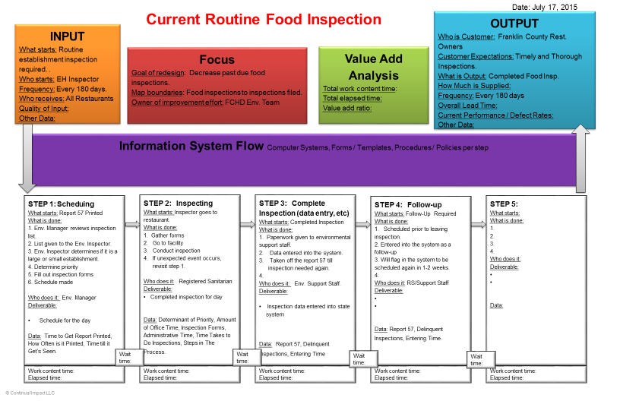

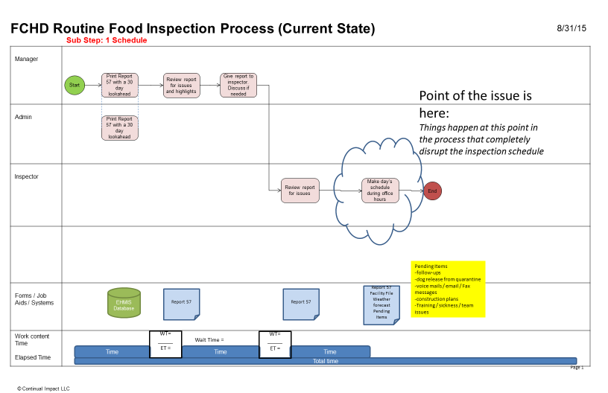

Data Review Findings:

There are 219 unique establishments that are part of the 605 and 607 cost centers that need inspection from a two year pull of data. Of those, nine are closed and 6 are newly opened which leaves 204 facilities that should have had 4 inspections in the last two years

70 of these establishments had 2 or less inspections =>> 34% obviously out of compliance

12. Conduct Cause and Effect Analysis (Priority issues and solutions from Cause and Effect Analysis)
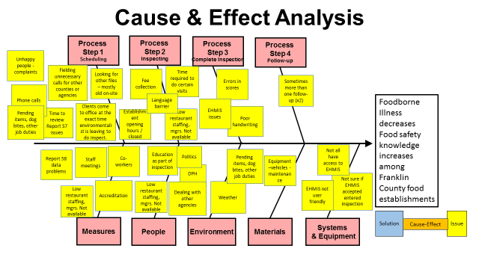
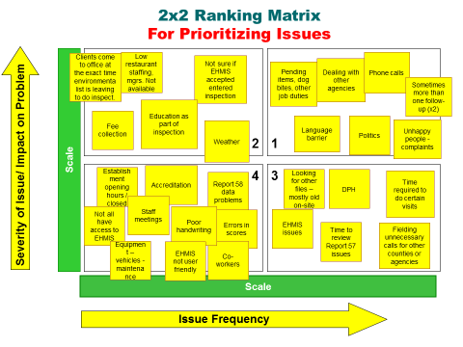
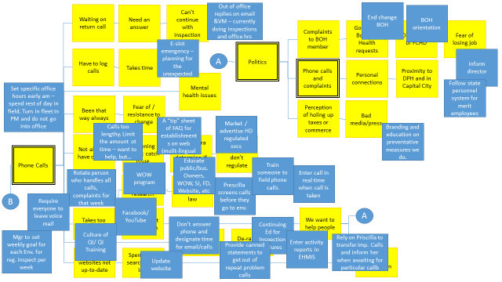

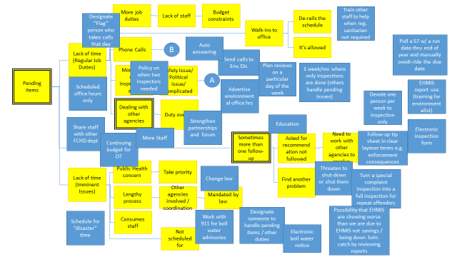

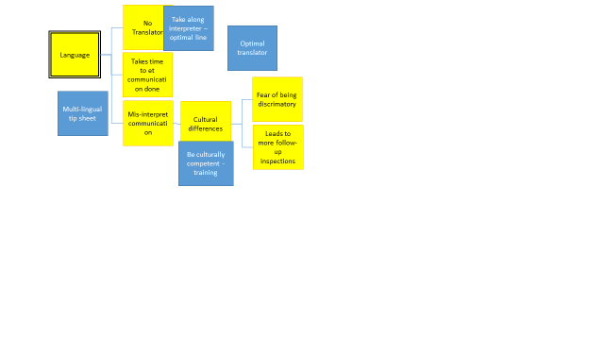
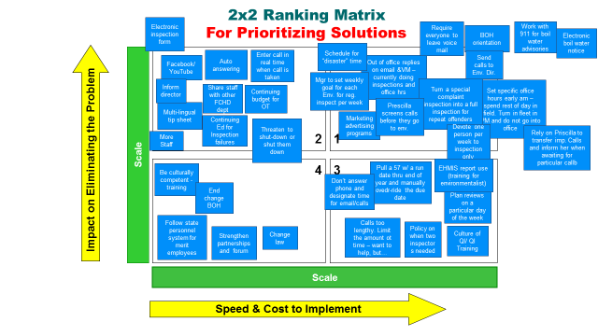

13. Improvement Hypothesis (Summary of potential means to achieve goal)
Issue | Improvement | Expected Results
WORK PROCESS | IF… we create a better defined process for handling incoming calls, create goals for weekly inspections along with better planning, and turn repeat special/complaint inspections into full inspections | THEN… staff will be able to perform one regular inspection of cost center 605 and 607 food establishments every six months. This will increase inspection compliance from a current level of 65% to 100%.
JOB AIDS | IF… we create better job aids and messaging for handling calls, automate activities like boil water notices and provide translation capability | THEN… staff will be able to spend more time on inspections and other duties, supporting the work process goals above.
OUTREACH | IF… we market and advertise our regulated services better through various media, improve education and make our email and voice mail messages better | THEN… we will reduce the need for extensive engagements outside of inspections and other duties for a number of customers. This will allow for more time conducting inspections and other duties required by staff and support the work process goal above.

_ TRY _
14. Test Hypotheses (How will you test the potential solutions?)
- Update the project schedule For trial and learning)
Tests | How | When | Who | Successful if…
Weekly planning and scheduling | Using the 57 report and the inspection look ahead data, create a mock schedule. Simulate walk-in callers and determine how communication is conducted. | Thu | Kendra and team | Schedule is produced by team and flex points are understood by all. Walk-in interruptions will be routed to manager for disposition and not handled by other team members.
 | Build next week’s plan | Thu | Kendra and team | Schedule will be built with inspection list and existing other pending duties
New phone messaging | Dial into FCHD phone system as a customer. Listen to message and navigate to Environmental team and also to imminent health hazard reporting area | Thu | Becki | New message will be available.  Navigation to Environmental Team will be routed to Team Manager’s line and imminent health hazard reports will be routed to the admin number.
New physical communication materials | Walk through environmental offices and determine office hours | Wed | Kaizen Team | Signage will be clearly posted showing office hours at the front entry and also at the environmentalists offices.
Office hours process test | Observe office hours and processing of pending issues | Fri | Kaizen Team | Strict control of hours will lead to team getting into the field promptly at 9:30 and interruptions will be managed by Manager.

15. Results: paste graph/table of actual trial performance

Area | Test | Test Output | Test Pass/Fail
Weekly planning and scheduling | Using the 57 report and the inspection look ahead data, create a mock schedule. Simulate walk-in callers and determine how communication is conducted. | Schedule created. Manager took all queries during simulation | Pass
 | Build next week’s plan | Plan successfully created | Pass
New phone messaging | Dial into FCHD phone system as a customer. Listen to message and navigate to Environmental team and also to imminent health hazard reporting area | Phone messages were successfully changed and are forwarded to the correct extensions. | Pass
New physical communication materials | Walk through environmental offices and determine office hours | New signage posted at front and on offices. All are visible | Pass
Office hours process test | Observe office hours and processing of pending issues |  | Pass

_ LEARN _
16. Learning (For the trials, what worked and did not, why and what are you doing as a result? Is the result repeatable?)
Reasons | Learning: Why? | Direction: Actions to be taken
+Weekly schedule meeting test fount that we weren’t looking at backlog | Testing helped up find holes in our thinking so that we ended up with a better process. | Continue to test in events.
+ Marking, advertising, and outreach activities got done during event  + We had someone on team who could change phone system | If communication is needed, ensure that someone can represent that on team so that you can get this work organized and done during the event. | Address communication when selecting the team members to ensure it is covered.
+Pilot test day was pretty typical of what we experience  - Holiday weekend followed the event week  - Don’t have normal plumbing inspector  - Can’t test for “disaster” scenarios | Test or simulate testing of a typical day so that we know whether our schedule method our average work (what we are targeting in this event). | Try to schedule testing for typical days or simulate a typical day at follow-on events.
+ A method to create a master list for inspections was figured out | Have broad data access on team is needed so that appropriate analysis and solutions can be created. | Continue to discuss data as part of prepare step, hold event in location where physical data is located, and ensure team has someone with broad access to system data.
- Can’t test for “disaster” scenarios | Test as much of process as possible so that the best process is created. | Plan for testing early (start on day 3, if possible) during event.
- Didn’t have knowledge to handle “8 ring” issue | Where you might need outside help, try to let them know in advance so that you might be able to use their expertise on an ad hoc basis. | Consider in future events.

_ INSTALL _ 17. Installation Plan (Steps to operationalize the new process and make it stick. Attach new process map below.)
- Update the project schedule or Action Items List

Area | What | Who | By When
Job Aides | Electronic boil water notice | Jenny | Checklist 12/31/15  Reverse 911 6/30/16
 | Working with others | Brittany | Cards for Environmentalists desks 9/11/15  All staff training 12/15/15
Outreach | Website / Facebook update | Becki | Website Jan 2016  Facebook 9/8/15
 | Business cards with office hours | Priscilla | Stickers 9/10/15  Reprint cards TBD
 | New signage posted on door | Becki, Judy, Brittany | Door wrap 10/30/15  Temp. sign 9/2/15
 | State Journal Article | Debbie, Wes | 9/13/15
 | Working on Wellness (WOW) program | Environmental Team, Debbie, Judy (script) | Air 11/30/15  Script 9/3/15  Media Release 9/5/15
 | Board of Health Reports | Brittany, Kendra | Quarterly report 11/9/15  Spotlight Feb 2016
 | News & Views article | Brittany | 9/30/15
 | Phone Recording and Voicemails, email signatures and out of office updates | Becki (phone, VM)  Jenny (email, out of office) | Recording 9/11/15  Voice Mail 9/2/15  Email signatures 9/11/15  Out of office 9/11/15
 | Content for Cable 10 Scrolling Ad | Judy | 11/30/15
 | Chamber Newsletter | Wes | 9/2/15
 | Call Matrix about ring numbers | Becki | 9/3/15
 | Brittany access to EHMIS | Jenny | Request sent 9/3/15  Access 9/30/15
Work Process | Develop master list | Morry, Brittany | 9/4/15
 | Weekly planning meeting - Mondays | Kendra | 10/5/15
 | Priscilla to do food safety classes | Jenny, Priscilla | Hand off 2/3/16  Ride along 2/3/16
 | Fax out of county dog bite to appropriate location | Priscilla, Jenny | 9/8/15
 | Kendra screen complaints (follow-up to regular) | Kendra | 10/5/15
 | Meet weekly to set and review plan | Environmental Team | 10/5/15
 | Schedule for “disaster” time adjustments (who handles if…) | Kendra | 10/5/15
 | Justin Carey follow-up | Jenny | 9/3/15
 | Job Aid for creating measure | Brittany, Morry | 9/4/15

18. Measure Success
- Attach graph/table of installed performance measures
- Attach photo of current Continual Improvement System

