SCPHS AP Referrals Current Process Map

= input = PHS agency AP referral made = agency = action

Refuah

Liberty Pregnancy Center

Buys pregnancy test at store

CRMC ER

Keeps pregnancy secret

Proceeds to confirm pregnancy via provider

1st Way Life Center

Health Clinics

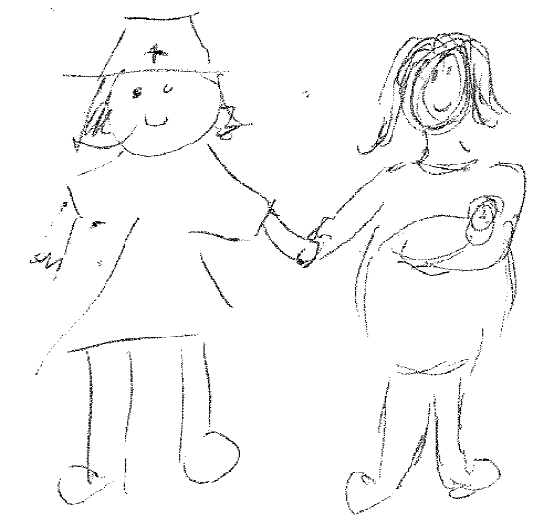

Confides in service provider

Community Services

Hudson Health Care

Fidelis

NO

Enrolls in Prenatal Care

YES

Has insurance?

Planned Parenthood

NO

YES

PHS

**PHS AP REFERRALS**

CHWP

School RN/staff

Job Corps

Crystal Run Healthcare

BOCES

HeadStart

Recovery Center

Decides to engage in Prenatal Services

CR Urgent care

Hudson River Health Care

HF

Women’s Health Center

DFS

MISN

WIC